Portfolio MAP

Fonteyne Joost

Contents

Document notes 3

Low-tech proposal (not used) 4

Advantages 7

Disadvantages 7

Questions 7

Collecting hardware 8

Platform 8

IR vision 8

Programmer 9

Power harvesting 9

Motion sensor 9

Profiler hardware 9

Selecting software 10

FOMO 10

MobileNetV2 and FOMO 10

Workings of FOMO 12

FOMO conclusion 13

Edge impulse 13

Coding environment 13

Profiler software 13

Learning to use the power profiler. 14

Blink power consumption 14

Deep sleep 14

Arduino ide vs esp-idf 15

First time running a model on the ESP32 16

Defining the system 18

Movement detection (discarded) 19

Sensor water penetration (flawed experiment) 20

Movement sensor energy consumption 20

Movement sensor with the use of an interval 23

Interval time 23

Time in between intervals 24

Interval with movement sensor experiment 24

Power consumption movement sensor vs no movement sensor experiment (NOT USED) 26

No movement sensor 27

0 crabs detected 27

10 crabs detected 28

With movement sensor 29

0 scans 29

1 scan in 10s 29

2 scans in 10s 30

3 scans in 10s 30

4 scans in 10s 30

5 scans in 10s 30

Redoing without movement sensor 30

0 crabs V2 30

Experiment result 31

IR visibility 31

4 leds at 250 ma total 32

8 leds at 500 ma total 32

Diffusing our leds with sandpaper. 33

8 LEDs at 620 mA in water 35

Breaking waterline clear tray 8 LED’s at 620 mA 37

Breaking waterline opaque tray 8 LED’s at 620 mA 37

Breaking waterline clear glass 8 diffused LEDs at 620ma (FINAL) 38

Tracking 38

Altering current modus operandi to accommodate tracking 38

Centroid tracking (FINAL) 39

The job assignment problem 40

Implementing tracking / counting with branch and bound 40

How and why does branch and bound work? 40

Power consumption/FPS with movement sensor altered for tracking, see section tracking (deprecated) 42

Final model (FINAL) 44

Gathering training data 44

Training the models 44

Deploying the model 45

Model accuracy 45

Model 1 dirty data accuracy 45

Model 2 clean data accuracy 46

Accuracy conclusion 46

Final power consumption (FINAL) 47

Baseline 47

1 s deep sleep interval 49

No crabs detected 49

1 time crab detected 50

2 consecutive crab detections 50

3 consecutive crab detections 51

4 consecutive crab detections 51

5 consecutive crab detections 52

6 consecutive crab detections 52

7 consecutive crab detections 53

8 consecutive crab detections 53

9 consecutive crab detections 54

Conclusion 54

Final test and conclusion (FINAL) 55

Conclusion 56

Final setup description (FINAL) 56

General overview 56

LED lightning circuit 57

Platform 57

Model 58

Counting and tracking 58

# Document notes

This document is about an attempt to create a monitoring sensor for the Chinese mitten crab with the focus being on power consumption and accuracy. This document contains the full report of my (Fonteyne Joost) time working on the subject. Mostly everything I did over multiple iterations of the system is described in here. So, a lot of things did not make it to the final version. It can also happen that something later in the document contradicts something earlier. This is because this document really describes the journey of coming to the final setup. I of course went over the document a few times and added knowledge from the future to certain sections to try avoiding confusion and contradictions. This document contains experimental results but also ideas and thoughts. It was made over many months; it was originally a mix of Dutch and English, but I decided to translate everything to English to make it easier for the reader. This document will not include specific code for everything I do, al the code used can be found on the github. I will include a chapter that accurately describes the final setup and how to reproduce it at the end.

Invasion of the Chinese mitten crab

Development of a monitoring sensor: sensor alternative

# Low-tech proposal (not used)

The aim is to develop a monitoring sensor that can map populations of the invasive mitten crab. Before me, this has been the subject of research for a year. They then found that a camera with a raspbery pi, an object detection algorithm and a tracking algorithm was a good solution. However, they did not have good conclusive results because the dataset they trained their model with was not extensive enough. After reading the paper, I thought it might be possible to work out a simpler more low-tech way. I then spent a little time working out a 3d model for a trap that could count crabs without too many complicated electronics. After pitching this idea to my supervisors, there turned out to be some holes in this idea. The biggest being that I am obviously doing a master thesis in the electronics-ICT direction and then deliberately avoiding electronics and ICT might not be the best idea. Hence, nothing more came of this idea, but I am adding it to my portfolio here anyway because I had put some time into it, and it was part of the process as it were.

I think it is possible to make a decent crab counting sensor without the need for more advanced technologies like machine learning etc. I hope to accomplish this by making use of some of the natural characteristics of the crabs. The main ones being: they can survive outside of water, they can climb vertically on a mesh and they are the only species found in Flemish waters with these two characteristics. This sensor would consist of a tube that is laid flat on the river bed aligned with the flow of the water to not disrupt the natural flow. Above the tube is a smaller tube filled with air. The crabs can reach this air pocket by climbing a mesh that prevents them from going straight in the ground tube. This mesh stops the crabs but lets water, mud, small stones and small organisms pass freely. Once in the air pocket the crabs would move forward and fall into the water tube again. While they are falling they can be counted with a sensor that works based on the disruption of a light beam. They can not go back since the exist does not have a mesh, preventing a crab from being counted twice. The whole setup is held in place by a heavy piece of stone.

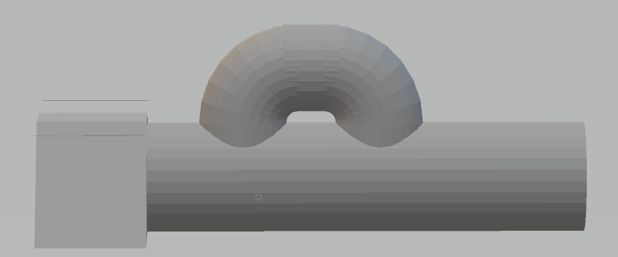

1: side view

The front of the picture above is the weight to keep the contraption at its desired position. The middle is the ground tube, which rests on the river surface and is filled with water. The top is the air/counting chamber. It is important that the contraption never rolls over otherwise the top chamber can fill with water. That is why the weight at the front has a trapezoid shape.

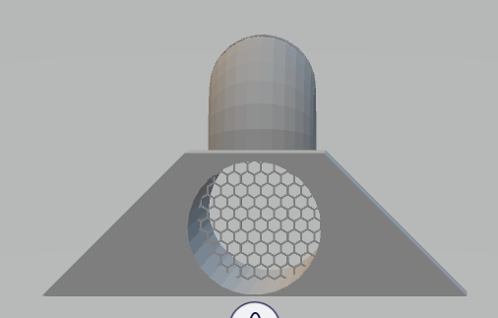

2: front view

The mesh is located right after the first hole leading to the top chamber. Giving access to the entrance of the top chamber but not to the exit. 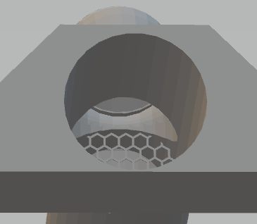

3: top chamber entrance

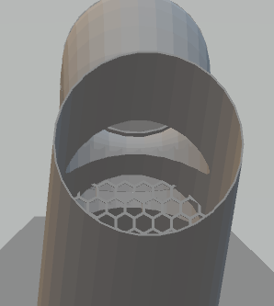

4: top chamber exit

It might be necessary to make the top chamber longer to prevent the crabs from climbing up at the exit again. But in general because of the crabs migrating behaviour I do not think many will try to go against the alignment of the trap (trap has to be aligned correctly ofc.) The trap in the pictures is configured to count crabs going with the flow of water. The trap can also be used for crabs going in the other direction by changing the position of the weight from the front to the back.

The crabs are counted when they interrupt a light source while falling from the end of the air chambre back into the water tube. They can not go back up because there is no mesh to climb at the exit.

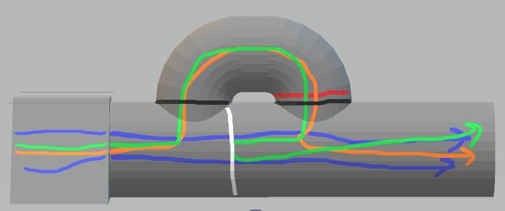

5: route illustration

Blue: waterflow, black: waterline, white: mesh, red: counting sensor, orange: crab route, green: crab trying to go back.

The light beam sensor sends signals trough a waterproof cable to the shore. The data arriving at the shore is processed by a microcontroller (add 1 for each pulse to count). From here on the data can be stored on site and await collection or can be transmitted trough a low power wide area network.

|  |  |
| --- | --- |
| Advantages | Disadvantages |
| Low-tech | Tube can clog |
| Easy to place/ maintain | Air chamber can fill with water destroying equipment |
| Natural waterflow not disrupted | Mesh would catch bigger rocks or would not catch smaller crabs |
| Low maintenance | Crab might prefer other route |
| Low cost | A lot of crabs might clog the system |
| Crab can not keep standing in front of sensor | A lot of crabs might give some inaccuracies when counting |
| Crab only counted once if we can assume that they don’t turn back and go around the contraption back to the entrance | Crab can be counted twice if it for some reason decides to go around the contraption and enters from the entrance again. |

## Questions

1. Can we assume the crabs to be evenly distributed over the ground surface of the water body?
   1. If yes -> can use math to calculate approximation of crabs passing point in river.
   2. If no -> need some sort of funnelling system to only allow crabs to pass trough certain points without disrupting natural water flow.
2. Do crabs prefer to go trough tubes? Or do they hate it?
3. Are crabs smart enough (or maybe instinct or something) to go to the upper air chamber instead of just all clogging the entrance or even preferring to move back?
   1. If no -> Can angle the mesh a bit to smooth transition
4. What is the smallest space a small crab can fit through?
   1. To decide optimal mesh size
5. How long can we assume this system to remain operational until segment build-up, rocks and plants clog it?
6. …

So much for that idea. After this, I had concluded with my supervisor that it was best to just continue working on the work of the 2 people before me. With an emphasis on using as little power as possible. I will try to achieve this by using a viable model as light as possible on the lightest possible platform and possibly doing some kind of energy harvesting with, for example, a solar panel.

# Collecting hardware

This is a practical objective and I need a lot of hardware for this. This can sometimes be tricky because ordering things and waiting for them to arrive can sometimes take a long time. Some of my components ended up taking longer than a month to arrive. It is also difficult to determine in advance exactly what you will need.

## Platform

The first thing I had to decide is what platform I want to work on. People before me used a raspberry pi, however, I want to use as little power as possible and the raspberry pi is just not efficient enough for that right now. After considering various options, I finally landed on a kit called ESP32-cam. Which, as the name suggests, consists of an ESP32 board connected to an OV2640 camera module. This board is small, cheap and economical but still promises to perform tasks like object detection etc. You can also find some tutorials online using this kit to do similar things to my goal, so ideal. Of course, the question remains whether it is really that good, but I can only experience that myself. The ESP32 is a dual core processor that claims to consume significantly less power than comparable processors and also has multiple low power modes. It also features pins on which the ESP32 can be woken up so you can let it sleep until when it is really needed. Using its deep sleep capability the ESP32 can run on very little current. The ESP32 also has wifi, bluetooth and low power bluetooth. This could possibly be of interest for transferring processed data or sending photos to the cloud for processing there to get more accurate results. The ESP32 has 520 kb of ram and 4 mb of flash memory. The esp32-cam development board comes with an integrated sd card reader. This card reader severely limits the amount of free GPIO pins we have but makes storing for example pictures a lot easier.

## IR vision

One drawback of the ESP32 cam kit, however, is that the included camera does not have night vision. Which is important since crabs don't like bright light and it can get quite dark underwater, especially murky water. The setup is also expected to run 24/7. Fortunately, the OV2640 can be modded to capture IR light as well. I ended up doing this by cutting out the IR filter from the lens. A process in which one of my two cameras ended up dying. The crabs themselves are cold-blooded, so I also order about 5 IR LEDs (this will later prove to be way too little and I will end up ordering extra). Of course, these will also consume extra power so we want to use as few as possible, but these are not really expensive so I better have a few too many for when I find that 1 LED is not enough to see the crabs properly. The leds I ordered at the start of my journey were 940nm IR leds. I initially chose these ones because 940nm is completely invisible as opposed to the 850nm ones which online sources claimed where visible. However, after testing with the 940nm ones I came to the conclusion that they did not work very well. I had too little and after some more research it also turned out that most cameras standard cameras with an IR filter are better at capturing 850nm than 940nm (after removing the IR filter of course). So, I ended up ordering some 850nm leds that where advertised as high power focused leds. The 850nm was more visible but faintly so that was not a problem. They were however too focused for my application, so I ended up sanding them down in the end.

## Programmer

The ESP32 cannot just be programmed via USB either. That's why I also ordered a programmer. On one side it offers a USB port that you can connect to. On the other side it offers pins to which you can connect the ESP32 to program it. The specifications of this programmer are not important and not relevant for this project. It must of course offer the right pins to program the ESP32. I use the GND, 3.3v, TX and RX pins.

## Power harvesting

For the possible energy harvesting part, I decided to keep it simple and just use a solar panel with a regulator board that can also charge a lithium battery. Luckily for me, I still had a 9v solar panel lying around at home. Moreover, I also had a board that can store the energy from a solar panel between 6 and 24v in a battery while also having a usb output with 5v and max 1a. The ESP32 cam also wants 5v or 3.3v so this works out well. However later I realised that I need a lot of IR light so I need a lot of power for this. Even if it is just a flash of a few ms the total power consumption will most likely exceed 1a when the leds are on.

## Motion sensor

To get the energy consumption as low as possible, I also thought it would be a good idea to buy a motion sensor. That way, the setup only needs to run actively when something passes by. However, the classic PIR sensors are not an option here because the crabs are cold-blooded. Therefore, I opted for a microwave motion sensor. This works like radar by constantly sending out microwave waves and then catching them back using the doppler effect to find movement. The sensor I chose is the SEN0192. It can easily be connected to one of the ESP32's pins. The idea is then that the ESP32 cam goes into deep sleep and the IR lights are off until the motion sensor picks something up. How well this works in our setup (being underwater and sometimes fast-moving water) remains to be seen. One problem I already foresee potentially is that the moving water will constantly trigger the sensor which means we end up using more power than if we just use the setup without the sensor and leave it on constantly. But I think this is definitely worth testing once everything else is ready. Because there is potential to save some extra power this way anyway. (Note from the future: microwave does not work well in water, so I ended up discarding this whole idea near the end :/)

## Profiler hardware

To map the power consumption of everything, I use a nordic semiconductors power profiler kit v2. This can be used as an ampere meter but also as a source meter. I use it in source mode, which means that the power for the device being measured is supplied by the profiler. I use this specific one because it was given to me by my mentor. So, this was not a well thought out choice on my part, but I trust my mentor would not just give me something that does not work. After working with it for some time I can confirm that it is easy to use and works well and consistent.

# Selecting software

## FOMO

The 2 students before me used yolov3-tiny for their crab recognition. So, to decide what to use I first went to see if any new version of yolo had been released. This was the case with the latest already on version 7. There is also a tiny variant of yoloV7 so this is definitely a candidate. The newer yolo models require a more extensive dataset to work optimally, which was precisely the problem with the previous thesis. So, I decided to keep looking around. I also found a paper on underwater detection called: "ULO: An Underwater Light-Weight Object Detector for Edge Computing" which is thus perfect for my use case. The people of this paper had developed their own algorithm specifically for underwater applications and also made it available. Unfortunately, it turned out that they were using the Nvidea jetson nano as their platform. A platform I had previously rejected because, firstly, it costs a lot of money and secondly it already consumes more than a simple arduino. This made me a bit sceptical about reproducing the paper's promises on the ESP32, especially for my application where low power really does matter a lot. In the end, I had my eye on FOMO (faster objects more objects). FOMO claims to be very scalable from heavy GPUs to tinyML (which is what I do). This has the added advantage that I can therefore also possibly run a heavier FOMO version in the cloud and have the ESP32 send photos via its wifi or bluetooth. This is a handy alternative in case the ESP32 is not sufficient for my application after all. FOMO is a customisation of MobileNetV2 and claims to work well with smaller datasets.

### MobileNetV2 and FOMO

FOMO was developed by Edge Impulse to provide good accuracy even when the model is small enough and not too computationally difficult to run on small MCU’s. FOMO is derived from MobileNetV2 by google. The paper introducing MobileNetV2 shows that when compared to other CNN’s, MobileNetV2 has similar accuracy while being much smaller and a lot less computationally difficult. Making MobileNetV2 a good candidate for mobile applications. Later we will see that FOMO is a customization of MobileNetV2 that is even more focused on being small and not computationally difficult.

#### Depth wise separable convolution

MobileNetV2 utilises depth wise separable convolution to significantly reduce the number of needed calculations compared to normal convolution. Depth wise separable convolutions are made up of two parts. The first one being a deep convolution on each of the input channels. In the second part the results of the first part get stacked together and combined into one output channel by doing a point convolution (kernel 1x1). The image below shows a normal convolution on a volume with 3 channels.

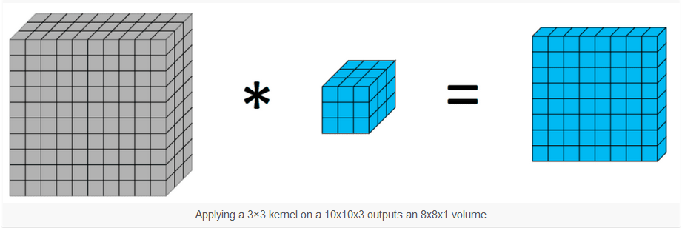

The image below illustrates the working of a deep convolution on one channel. This is done for each channel of course (so three times in this example). Like the normal convolution we start with one channel but unlike the normal one we also end with three channels as opposed to one.

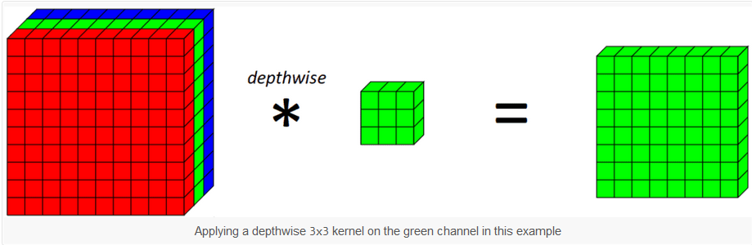

The image below shows the working of the point convolution.

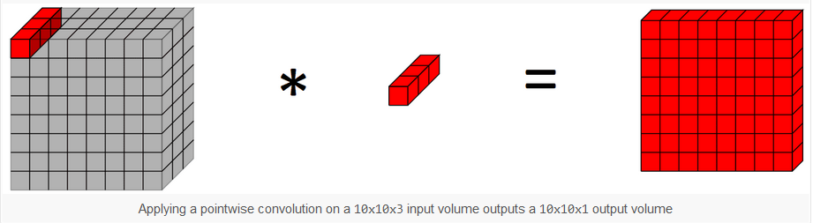

Let’s use an example to illustrate why this is more efficient. Say we want to do 64 convolutions on an RGB image to get 64 outputs. For a normal convolution that would take 3*3*3 {kernel}*64{the amount of outputs we want} = 1728 operations. Now lets calculate the operations for the same setup using depth wise separable convolution. 3*3*1{kernel}*3{three channels} [these two are the deep convolution which will leave us with 3 channels] + (1*1*3*64){point convolution brings outputs to 64} = 219. So in this example a normal convolution would take 1728 operations while the depth wise separable convolution only takes 219.

#### ReLu6

MobileNetV2 and by extension FOMO use ReLu6 or rectified linear unit 6 as its activation function. What this means is that negative values become zero and positive values stay the same but everything bigger than six also becomes just six. This hard cap at 6 is what differentiates ReLu6 from normal ReLu. This cap leads to increased robustness when used with low-precision computation. The image bellow illustrates the use of ReLu6.

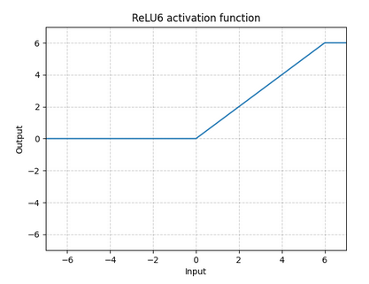

We use activation functions to give neural networks non-linear expression abilities. This allows them to better fit the result and thus improves accuracy.

MobileNetV2 also contains layers called “bottleneck layers”. In a CNN the bottleneck layers are added to reduce the number of channels in the network. Without them the number of channels usually increases with each new layer. The bottlenecking is done with a 1x1 convolutions with fewer output channels than input channels. After this block a normal linear activation function is used instead of ReLu6. This is because non-linearity at this stage could destroy possible useful features. Apart from here ReLu6 is used everywhere else as the activation function in MobileNetV2.

### Workings of FOMO

#### heatmap

FOMO was developed with the aim to be as computationally easy and small as a classification model. But also retain the ability to count and position found object like a detection model. Taking the best of both worlds. To achieve this the original image is split up into a grid with each grid being made up of 8x8 pixels by default. So, an image of 512x512 would translate into a grid of 64x64 with the default settings. A normal image classification model would use convolution layers with each new layer being a diffused lower resolution image of the layer before it. It would do this until we arrive at a 1x1. FOMO cuts out the last layers, leaving us with a per region class probability map. The resolution of the probability map is determined by at which layer we cut of the image classification. FOMO then uses a custom loss function which forces the network to preserve the locality in the final layer. So, we end up with a heatmap of where our objects are. So, in our earlier example we end up with a 64x64 map, with each piece containing a probability for the objects we are looking for. A possible problem can occur if two objects are too close to each other. When they occupy the same cell only one will be registered. The solution to this is to make sure that you use an appropriate heatmap conversion ratio. At a ratio of 1x1 for example, every pixel becomes its own grid in the heatmap, and it becomes possible to detect a lot of verry small things verry close to each other.

#### Centroids

FOMO unlike most other models does not detect bounding boxes. This is not because it can’t, because it can. FOMO could just draw a box around activations in the heatmap. It does not do that because the developers found that most users don’t care about the bounding boxes and that bounding boxes are mostly a by-product of how other models work. To have a locality and count only the centre is enough. Detecting only centres makes it easier to count objects that are close to each other.

### FOMO conclusion

FOMO seems to be a good fit for our use case. It is small and not verry computationally intensive, allowing it to run on our chosen MCU. FOMO’s characteristics inherited from MobileNetV2 and later added by the Edge Impulse team make it able to accomplish this while maintaining accuracy. Its use of centroids over bounding boxes is no problem for us, if anything it makes counting the crabs easier. FOMO is also the only model that is available for use in object detection on the esp32 in the edge impulse portal. But I only found out about this after choosing FOMO. I first arrived at FOMO and then at using edge impulse to generate my model. So, I guess this sort of validates my choice.

(All info about FOMO found in following papers: [10.1109/TIM.2023.3265119](https://doi.org/10.1109/TIM.2023.3265119), <https://doi.org/10.48550/arXiv.1801.04381>, <https://doi.org/10.48550/arXiv.1704.04861> and on following sites: <https://machinelearningmastery.com/using-depthwise-separable-convolutions-in-tensorflow/> , <https://docs.edgeimpulse.com/docs/edge-impulse-studio/learning-blocks/object-detection/fomo-object-detection-for-constrained-devices> )

## Edge impulse

## Coding environment

To program my ESP32, I need a development environment. My first plan was to do this via the arduino IDE. There are many tutorials explaining how to do this so that's not a problem. However, my supervisor advised me to try ESP IDF because via arduino IDE you don't have access to low power and deep sleep mode etc. Which are obviously important features in my context. So, I ended up chosing to start using the esp-idf extension in sv code to program my esp32. Later I switched back to the arduino IDE anyway. Because I discovered that deep sleep does work in the Arduino IDE. I later discovered in an experiment that programming with the arduino IDE seems to use a bit more power. But the arduino IDE is just so much easier to use that I stayed with it anyway. If there is still time left, I could try transferring all the code to ESP IDF and see if there is really such a big difference.

## Profiler software

The ppkv2 can be controlled with a piece of software. To use the kit, you can connect it to your PC and use the nrf connect for desktop app to control the profiler and read results. This app allows you to turn the power on and off. It also allows you to adjust the voltage of the output. You can see the power reading in a graph which can be paused and turned on at will. You can also zoom in and select intervals to get readings for those specific intervals.

# Learning to use the power profiler.

## Blink power consumption

To master the operation of the ppkv2, I started by flashing a standard blink programme on the esp32. This programme will switch the blue LED on or off every 2 seconds. Basically, we should then observe a small difference in power consumption every 2 seconds with the ppkv2. After installing the right software, this appears to be the case.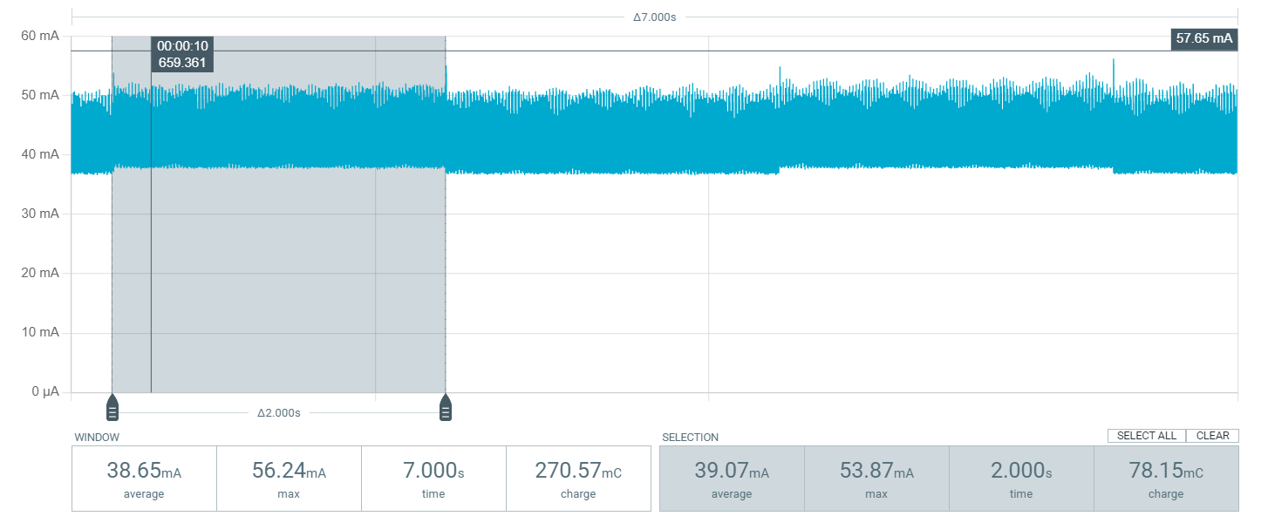

We can clearly see that a little more or less power is consumed every 2 seconds. This corresponds to the flashing of the LED. We also see that with a very simple programme, the esp32 consumes an average of 38.65mA.

## Deep sleep

Esp32 has several power saving modes. Deep sleep turns off almost everything, consuming very little power. But still just enough to run the low power coprocessor so that the command to wake up again can be given. This can be an external interrupt event via certain pins but also a built-in timer that expires. The graphic below is deep sleep with a timer as a wake-up event. The esp32 is set to go into deep sleep for 5 seconds and then wake back up for 1 second. 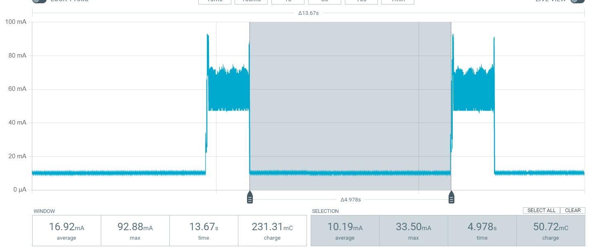

The code to go into deep sleep and wake up after 1 second or after an interupt on pin 12 looks like this: 

We see that consumption in deep sleep is around 10mA, which is in line with what is advertised online. (It is worth noting that in our final setup we read a current draw of only 6,5 mA during deep sleep.) In the active second, we see are around 50mA on average.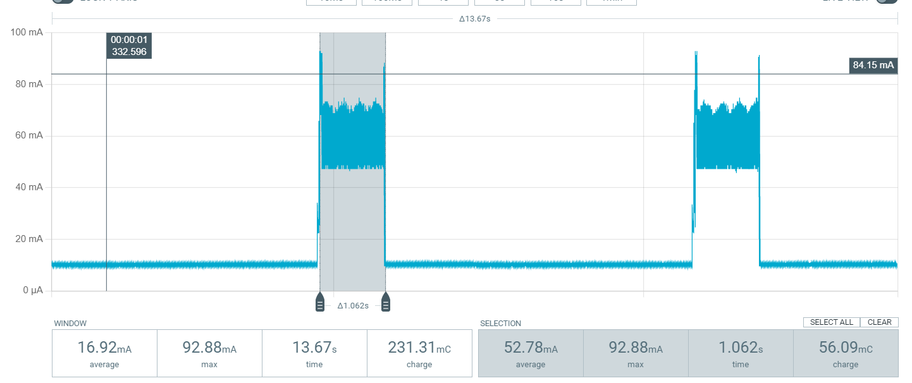

## Arduino ide vs esp-idf

The arduino IDE is much easier to use than vs code with the isp-idf extension. But when comparing the active power consumption for the first blink example (programmed with esp-idf) and the 2nd deep sleep example (programmed with arduino ide), it turns out that there is still a significant difference on this. Something I didn't expect. To confirm my suspicion, I will do the first blink example again, but this time with the arduino IDE.

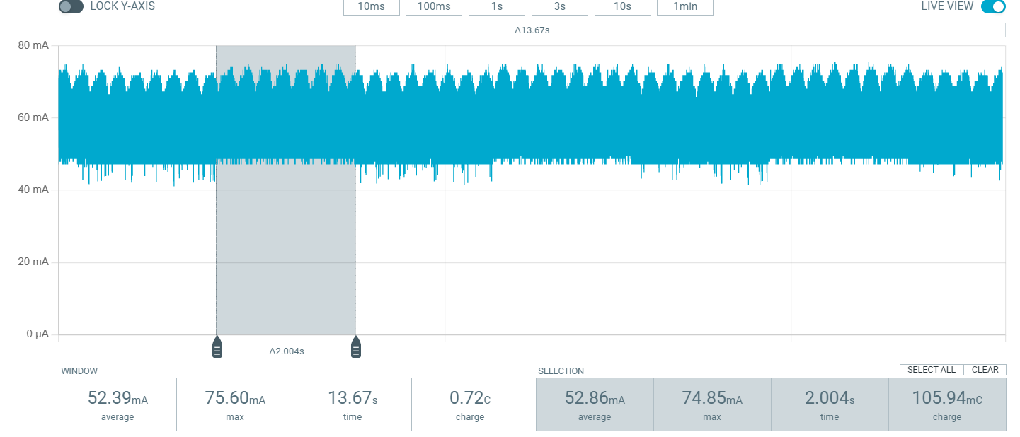

We now see a higher power consumption for what is essentially the same task. So, it seems that the use of the easier Arduino IDE comes with the drawback of consuming more power. Throughout the project I still chose to work with the Arduino IDE. Because that is what I’m familiar with and I also utilise some Arduino libraries in some of my code. The plan was to maybe try and port the final Arduino code to esp-idf if I still have time left.

# First time running a model on the ESP32

The used model is for recognising the presence of a car in an image. This is a model provided by edge impulse itself as a tutorial of sorts. This sketch uses a web server etc, so a lot of extra things that aren't actually needed. But this is a good starting point to learn how these models are generated and how to upload them. Later, I will try to get the consumption as low as possible by turning off all unnecessary functions.

//TODO these pictures are wrong and should be corrected. -> Sorry reader but I’m running out of time until the deadline and correcting an old photo that is not relevant to the final result and setup or even partly relevant is not my priority right now. Will try to correct later if time allows but I doubt it will haha :/ so apologies reader.

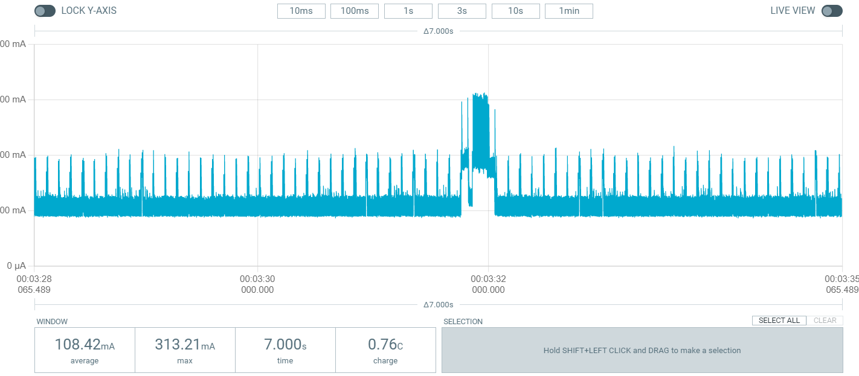

The short peak occurs when a client connects to the web server. The following image shows the consumption peak when the esp32 cam takes a picture:

We see a distinct group of peaks appear in our power profiler before the image appears on the web server. Sometimes this group is much longer and then it also takes much longer for the image to appear. But since this happens only somethimes, I assume this is an error somewhere. The following image shows taking an image via the web server and then running the model on this photo:

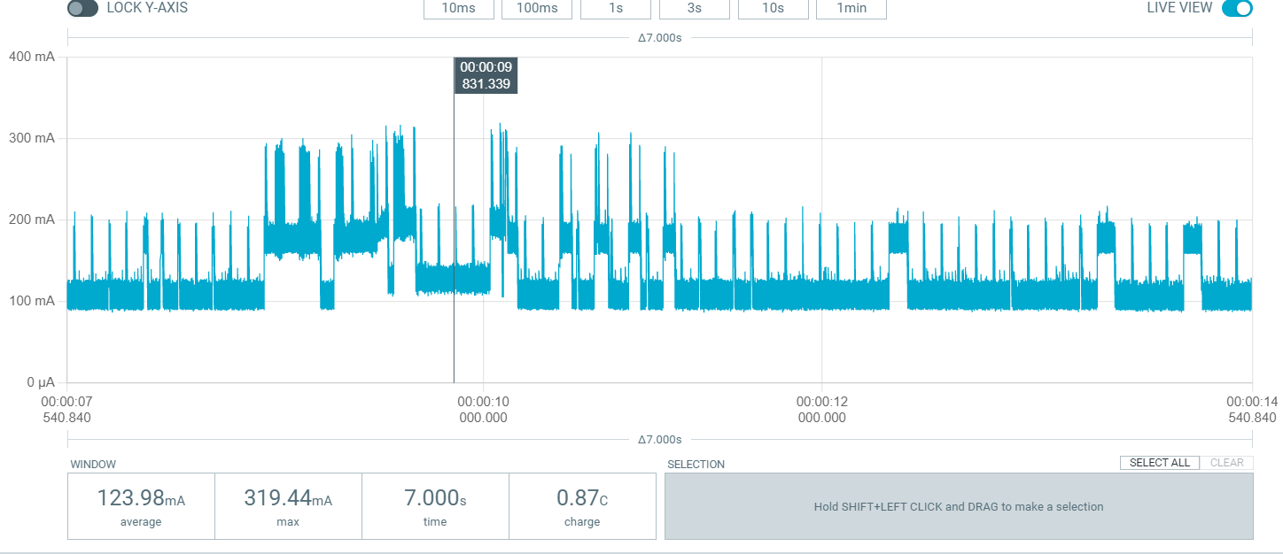

What we see here is the consumption when taking a picture plus releasing the model on this picture. Again, this group is much longer in exceptional cases, the same as when taking a picture. In this graph, no object was detected to make sure this profile is also correct when one is detected I also tested this once and this was just the same:

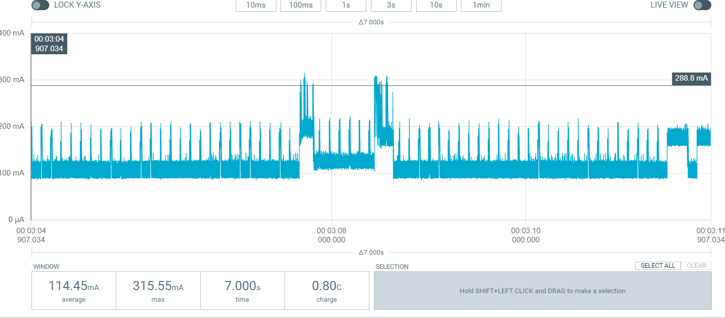

I do notice that the graph always looks slightly different with each new iteration, which is annoying to me. Because for me, it is nice if performing the same action always gives the same result. This is most likely due to the connection betweern the webserver and the user. The command to take a picture and to run the inferance is given by a user connected to the webserver. (In later tests I always get identical results in my profiler for the same action, even for running the model and taking a picture.) In general, it can be said about all the graphs that there are peaks of up to 300 mA. Taking a picture is always a distinct group and running the model is also always a distinct group. Sometimes the groups are a bit more compact than usual. The following picture shows the consumption when streaming video from the camera via the web server:

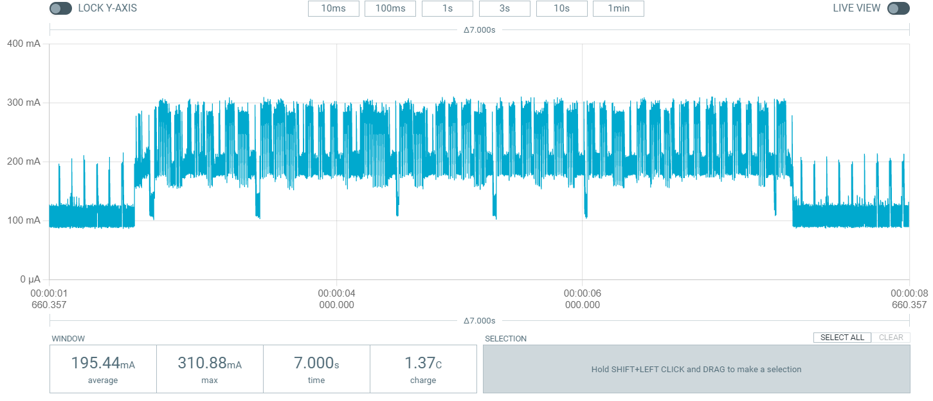

I think that from this picture we can clearly see when the video is being streamed. Unfortunately running the inference on the video is not an option in this example.

# Defining the system

The assignment: “developing a monitoring sensor” is a very broad one. Therefore, I want to narrow down the assignment for myself. I want to use the same principle as the group before me. So a camera with a machine learning algorithm behind it. But my focus will be on adapting this idea better to the use case. Specifically, focusing on making this system as energy efficient as possible. To achieve this and be able to ask and answer useful questions about it, I will divide the system into a few parts. The initial idea was that each parts feasibility and usefulness can then be examined individually. It does also make it much easier and clear to keep track of progress and allow multiple people to work on different pieces. After working like this for a while I unfortunately realised that this approach does not work well in this case. It did give me a good way to chop up the problem and a place to start. But I ended up doing a lot of unnecessary work. To give an example I did a lot of power profiling on different movement sensor scenarios. Only to realize in the head experiment that the sensor does not work in a big body of water. (My prior experiment to determine water penetration of this sensor turned out to be flawed and the results invalid) This is the result of working in pieces and putting a lot of work into a piece only to realize later that the piece does not fit into the puzzle. Anyway, the division I came up with at the time resulted in the diagram below.

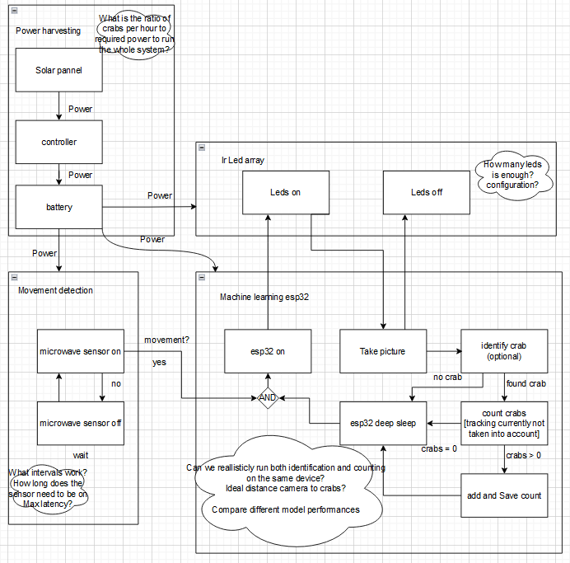

As you can see, the different components are: power harvesting -> Collecting energy from the environment to extend the operational life of the system. Movement detection -> Detecting movement consumes significantly less energy than taking a picture and running the algorithm, so this can be a good trigger for the system. Ir led array -> We need light to take a picture. Since crabs don't like ordinary light we choose ir here. Esp32 -> This is where the real magic happens, this is where we are going to take a picture and run the algorithm and keep count. The goal is to keep this part operational for as long as possible.

Now that the task had been divided into pieces, I started looking at and assessing each piece separately.

# Movement detection (discarded)

As already mentioned, we choose a microwave sensor here instead of a standard PIR sensor, because crabs are cold-blooded. This part immediately raises some questions that we will try to answer here. 1) Can our sensor penetrate through water without being influenced too much by it? 2) What is the energy consumption of this sensor and can we reduce it? 3) Is it interesting to work with an interval instead of leaving the sensor always on?

## Sensor water penetration (flawed experiment)

The sensor was held above a bucket containing 15 cm of water. (This was also not a very representative test, since in the final test the crabs were about 35 cm beneath the water surface. 35 cm is more representative of an actual river. {at least for the one I visited})

* Is movement under the bucket registered? -> sometimes, not reliably (in hindsight this was probably because the sensor does not penetrate the water well but has a wide detection range so sometimes detected movement on the side of the test setup)
* Is movement inside the bucket registered? -> yes, most of the times (No, again wide detection range made it look like this was successful but after testing later while eliminating the chance of false detection due to the wide range it was not.)
* Is movement of the water surface detected by the movement sensor -> Only bigger waves. (after checking again this result is correct)
* Do the movements of a very small objects (stone 1.5x0.9 cm) get detected? -> Hard to test but it seems like most of the times it is detected. (This is correct, the movement sensor appears to pick up on the movement of small objects)

## Movement sensor energy consumption

Test setup: movement sensor connected directly to power profiler.

The maker of the sensor advertises a max consumption of 60mA and a typical consumption of 37mA. We ourselves discover that the sensor consumes around 47mA when no motion is detected and the interrupt pin is not connected to the esp32.

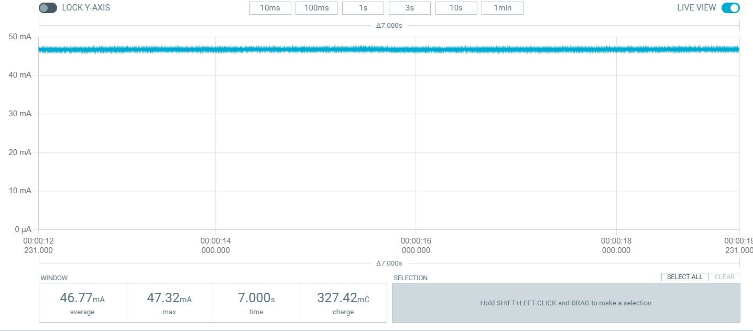

When detecting movement the graph looks like the picture below.

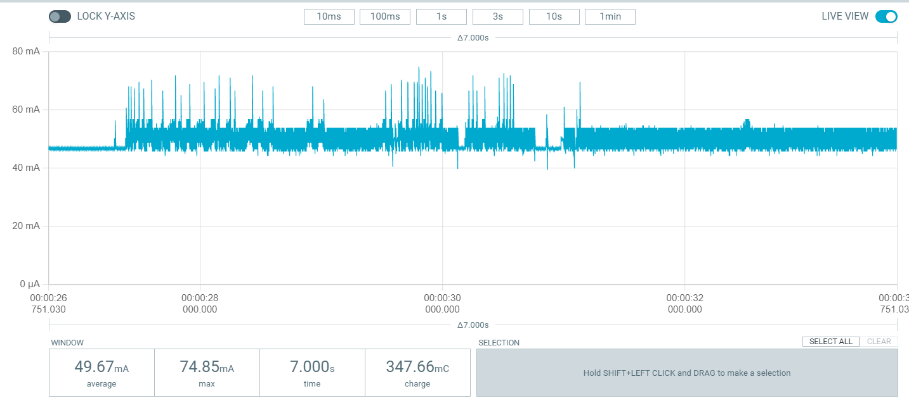

So, on movement we read a consumption of around 50 mA. After movement, this stays around 50 for a few seconds but with lesser peaks before dropping back to 47 mA. This appears to be about 10mA more than advertised on the seller's site. Keep in mind that in these tests the interupt pin of the movement sensor is not connected to anything. On start-up, we also see a short period with higher consumption that overtime drops to 47mA every time.

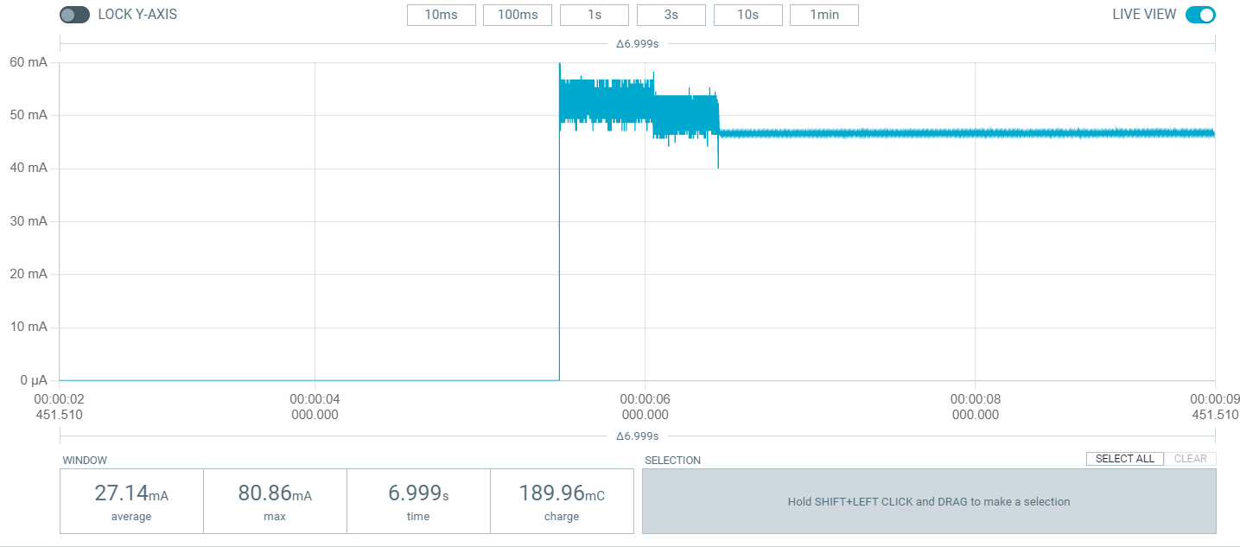

This startup consumption can be relevant when switching the sensor on and off. It also seems that the sensor is not operational during this time. I will later find out that no interupt signals are send during this time.

We could further reduce this consumption by unsoldering the power indicator LED and movement indicator LED. Although this is not a big saving, every little thing helps in a project like this. After doing this, we notice that in idle we only use around 43 mA and when motion is detected, we only see very short higher peaks. This is because the indication led now no longer turns on on movement detection.

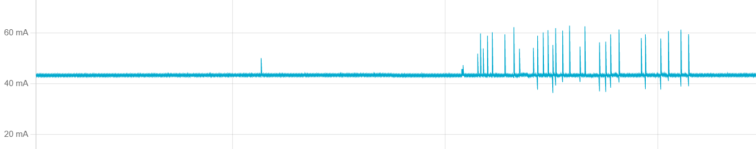

These small peaks most likely coincide with registered movement.

If we now connect the interupt pin of our sensor to the esp32, we see that the idle consumption goes back to 47 mA. But without the unsoldering, this would then be around 51 mA. Removing the motion indication LED also saves around 4mA when motion is detected. The crazy thing is that when connecting the interrupt pin to the esp32 we see that the overall power consumption is now lower when there is motion versus when there is no motion. Also, the initial startup peak is now higher (80 mA) but shorter. The consumption in the start-up phase is now also lower than the overall consumption. To illustrate, picture when switching the senor off and then on again (without indication LEDs and with interrupt connected):

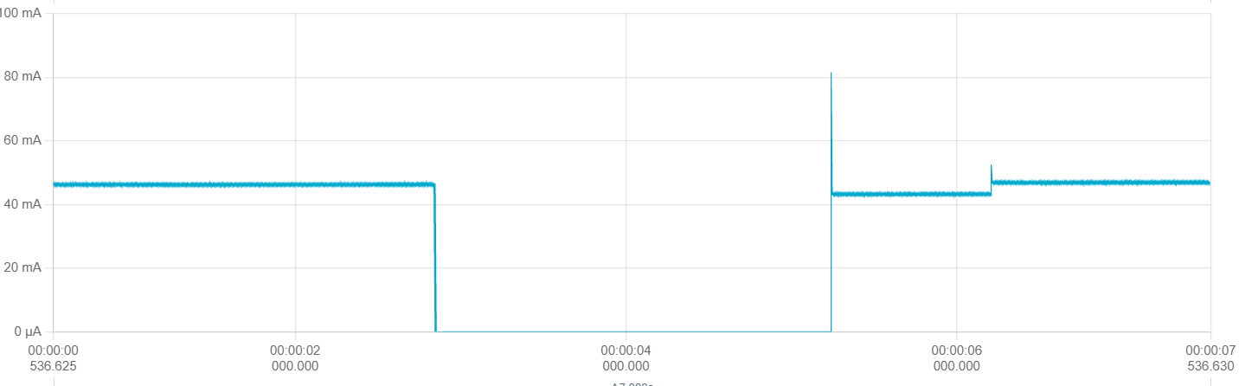

Now to illustrate the current draw on movement detection (highlighted area):

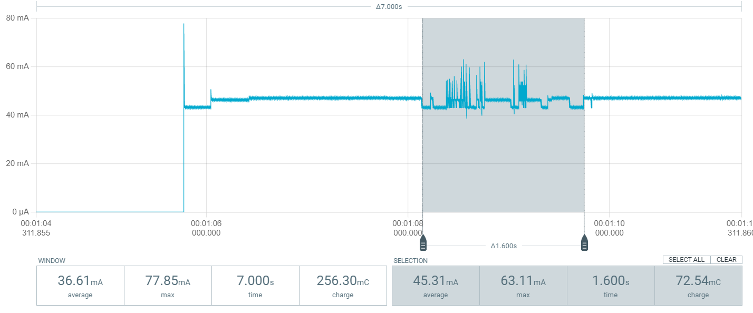

To conclude, the results here are a bit disappointing as 47mA is still quite a lot for our application. But this 47mA + the 10mA of the esp32 in deep sleep is still a lot less than the consumption between 100 and 200mA we saw when taking a picture and running the random model on the esp32 let alone the 680 mA consumed by Satish's setup in idle. So this is definitely an improvement, though not the big improvement I would have liked to see here. Maybe the next part, using an interval can save us even more.

## Movement sensor with the use of an interval

We can try using the motion sensor only every x seconds, and keeping it on for y seconds to save power. Important here is to know how long it takes from start-up before the sensor can detect motion. We also need to calculate the minimum value x needs to be to make a profit on our power consumption. The bigger x is the better of course, but a limit must also be imposed here because otherwise we may miss crabs. Ultimately, we also need to know the total latency of the system. Because it makes no sense to make x smaller than the time it takes the system to fully process 1 trigger.

### Interval time

Like previously mentioned we have a small amount of time on startup when a bit less current is drawn.

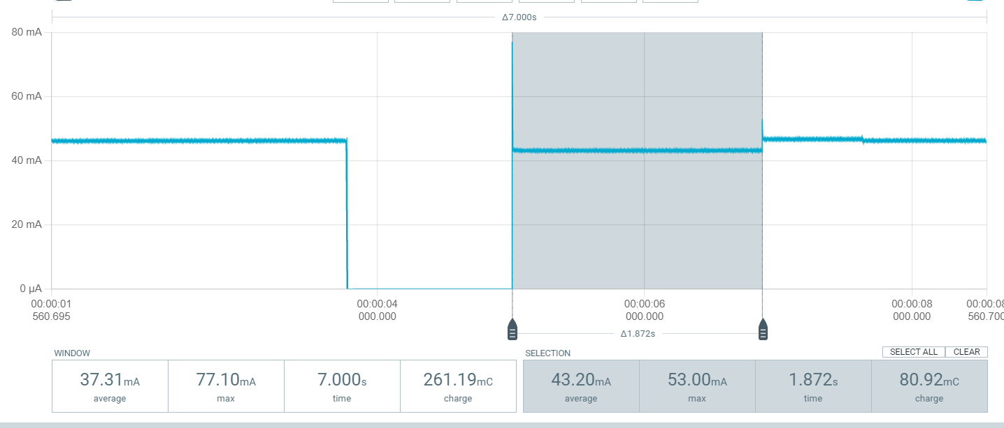

The annoying thing here is that this start piece is not always the same length on the profiler. In fact, empirically we find that there is a lot of variance on the startup time. Therefore, I think it is safest to ignore this initial drop in our calculation and just take idle consumption everywhere. This is because sometimes this peak only lasts a few milliseconds and sometimes a few hundred ms. So it is best to take our consumption a little too wide than too narrow because we cannot predict this duration in advance. So we will use 47mA throughout. When testing here, we also noticed that the sensor is not ready to detect motion immediately after start-up. We also see that the sensor always detects motion just after start-up, which may explain that first, slightly lower bit. This is hugely annoying for determining an ideal interval because, as mentioned earlier, the duration of this spike is not predictable. After many tests, I think we can put the initial start-up time at 2s. Often it is much less than 2s but we have to be careful here if we want to ultimately save with our esp32 itself. Similarly, if we're once over 2s, it's not a big deal either, we're only running our system once for nothing. Y, the duration of each moment in the interval should already be at least 2s. If we then take another 1s for detecting motion, we have a y of 3s at max 47mA. (which in hindsight is way too big considering the field of view and unknown speed of the crabs and also the tracking which becomes increasingly worse at lower FPS)

### Time in between intervals

Since we have found that the initial start-up phase consumes less than the normal state and, moreover, when motion is detected, it consumes less than normal, it doesn't really matter how much time there is between our intervals. We are always going to make a profit versus if we run the sensor full-time. We do need to remember to always run the sensor for at least 3s. Of course, we still need to choose a logically chosen reasonable time. (TODO average speed crab? -> not known and may depend from crab to crab so this whole idea was later rejected for this reason)

## Interval with movement sensor experiment

Parameters: tijd tussen interval = 5s, interval length = 5s

Clarification as to what is meant by interval: The whole system turns of for x seconds and then turns on for y seconds. During the time the system is on the movement sensor will look for movement, when movement is found a picture will be taken. After taking the picture the system will run an inference. (NOTE: inference run in these experiments is not the same as the model in the final setup! So, consumption and run time may vary) Movement in this experiment was evaluated during 1 second. The system would register the times movement was detected during this second. If that amount is higher than the set threshold, we take a picture at the start of the next second. (This has the advantage of introducing a threshold that can be adjusted at will but the disadvantage of introducing between 1000 and 0 ms of delay between the first movement and the taking of the picture. After this iteration of the setup this threshold was dropped because the added delay was not worth it.).

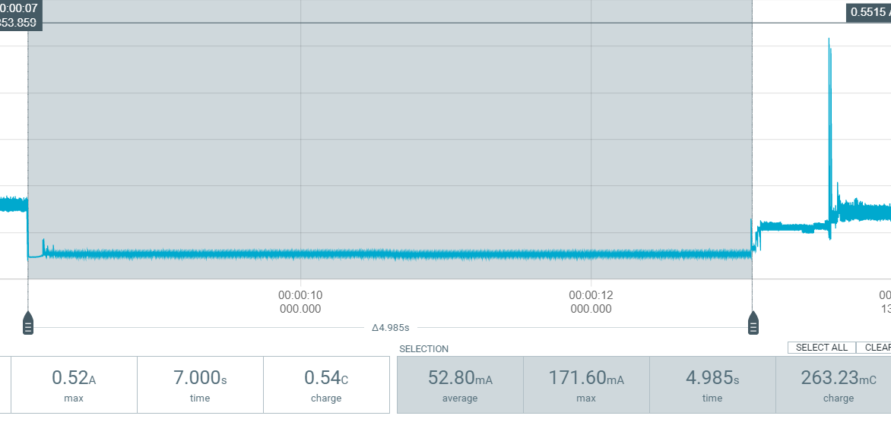

Picture aboce shows => esp32 in deepsleep, motion detector on

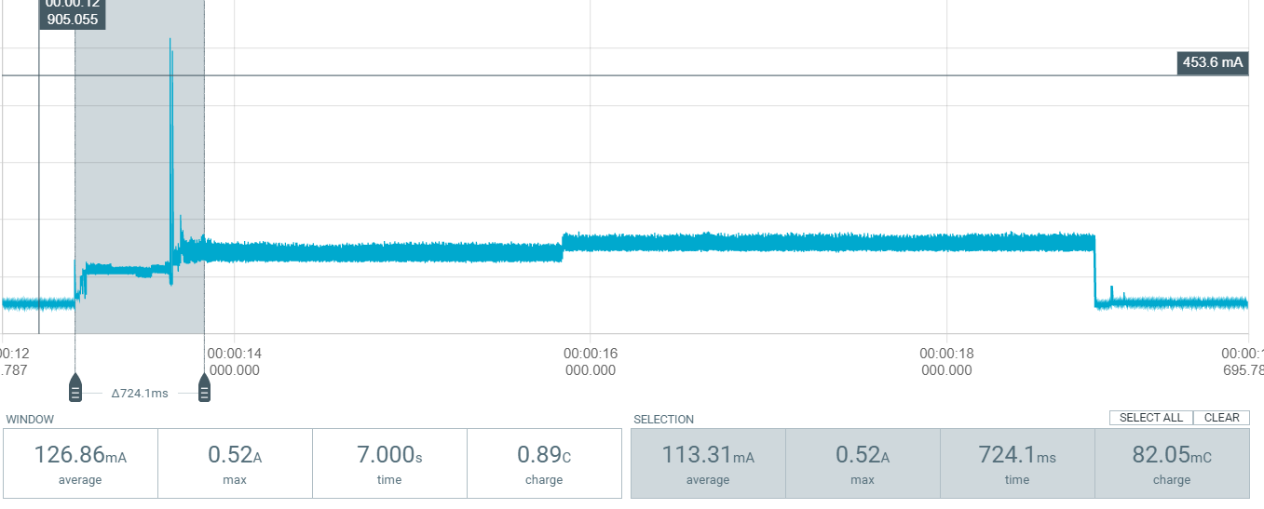

Picture above shows => esp32 coming out of deep sleep. Selected = time + current draw for esp32 to exit deep sleep. Not included in the 5s interval.

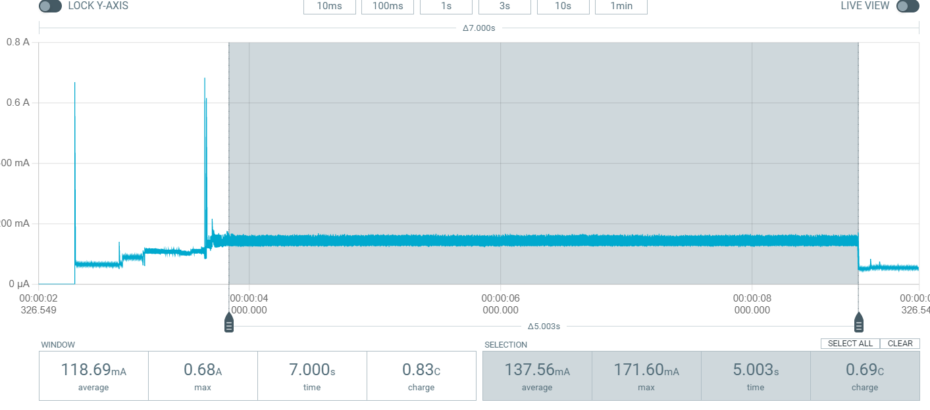

Picture above shows => esp32 active and microwave active, no motion detected

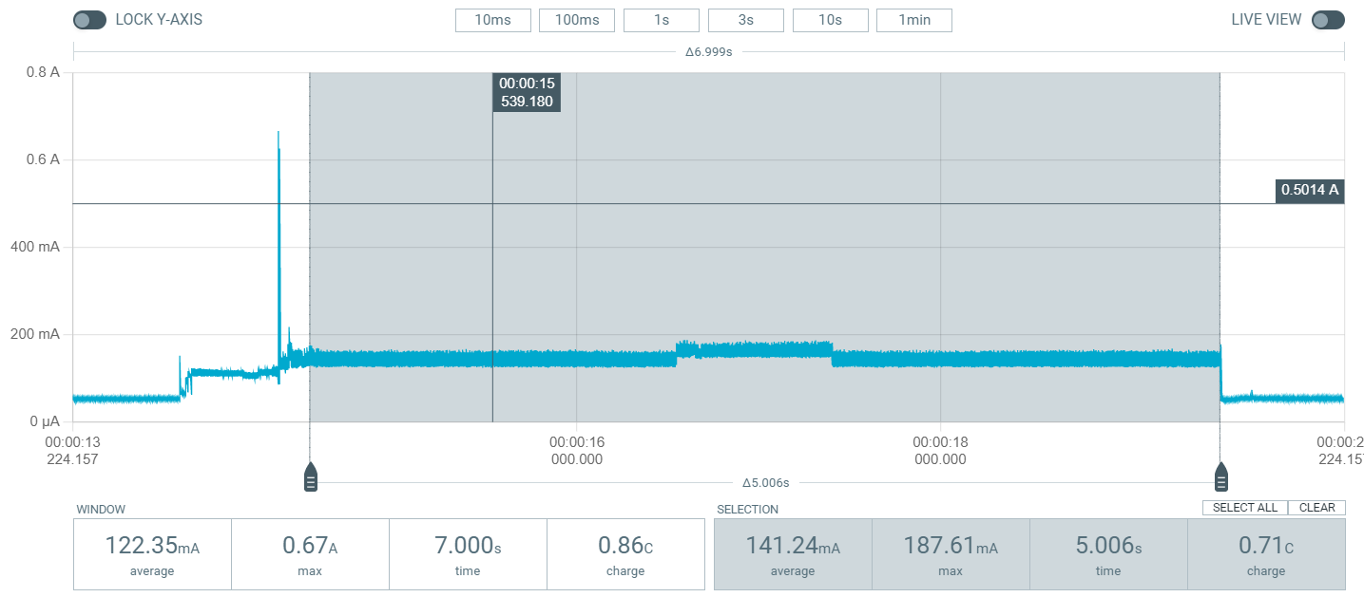

Picture above shows => esp32 active and microwave active, picture taken and inference ran starting at 2s mark. (Motion is evaluated every 1s so this means that motion was detected between 1s-2s, no more motion detected between 2s-3s because the signal does not start another peak at 3s)

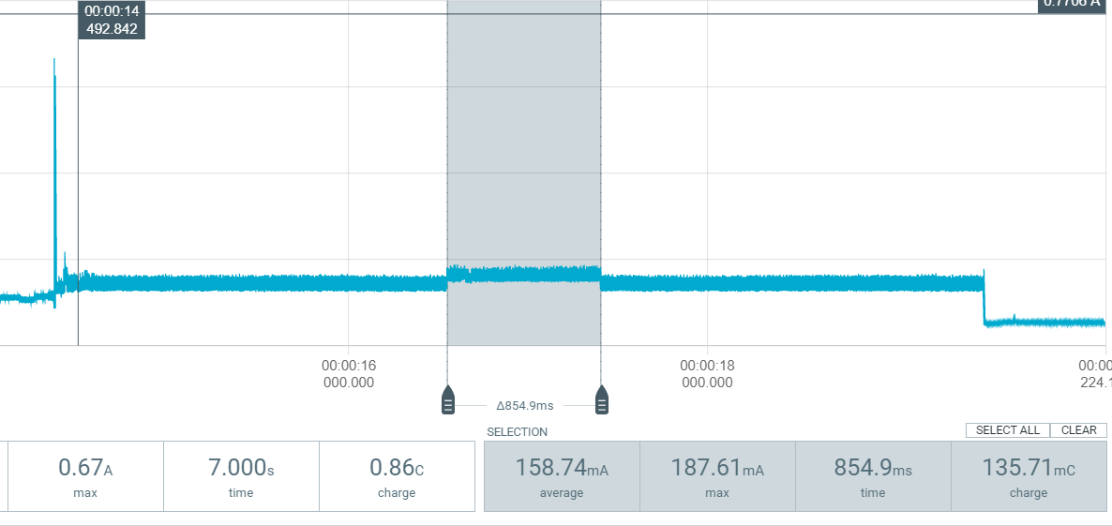

Picture above shows => time and power needed to take picture and run inference. (NOTE: not final model! At the time it was my model but later I ended up switching. So, not representative of the final system)



Picture above Shows => inference result (no crab detected in picture).

The speed of the crabs can vary greatly, not only between individuals, but also based on external factors. After checking with Jonas from the biology department I concluded that it is not sensible to assign the crabs an average speed. Therefore, the use of an interval cannot reasonably be evaluated. Of course, waiting for example 10s between each detection is going to save a lot of power compared to detecting every second. But because the lack of an average speed for the crabs there is no way to evaluate what kind of influence an interval of x seconds would have on the accuracy of the whole system. I wanted to minimize power consumption while maintaining accuracy. So, at least for now I will leave it at that. We found that when turning on the movement sensor it could sometimes take up to two seconds before it is operational this is really to much wasted time. The 1 second polling time for movement (the threshold implementation) is also not a good idea considering we want as little latency as possible on our system to run a tracker. For all those reasons this whole idea was discarded. We can still try and use the idea of lowering power consumption by introducing some down time but not in this way.

# Power consumption movement sensor vs no movement sensor experiment (NOT USED)

Compare power with use of movement sensor to without movement sensor

NOTE: At the time I thought this model would be my final one, but I ended up creating another one. The model used here is probably not that different in terms of current draw and runtime. But still, I can not say in good faith that these readings are still valid for the final setup. Also the final setup does not even use the movement sensor. So, later in this document you will find a power consumption section for the updated model and setup.

## No movement sensor

Take picture and run inference every second for 10 seconds, between 0 and 10 crabs detected do 10 times for every number of crabs to get average and standard deviation. I know from previous experiments that clocking in at around 850ms the inference for this model can fit in 1s. I chose to do it over 10s because I wanted to get an average over a few readings so that in the end I could hopefully state something along the lines of: “When we run less than x cycles during 10 seconds, using the movement sensor is more power efficient than continuously taking pictures”. I wanted to get an average and standard deviation because I was not sure whether the readings would be consistent. (In hindsight this was not necessary as every reading was about the same and any variance was most likely due to human error. It is hard to always select the exact same timeframe, especially when doing this so many times. But this time was not completely wasted. Now I at least know that this is not necessary for future readings and can prove this claim by referring to this section.)

### 0 crabs detected

Below screenshot of the first run resulting in an average current of 114.75ma

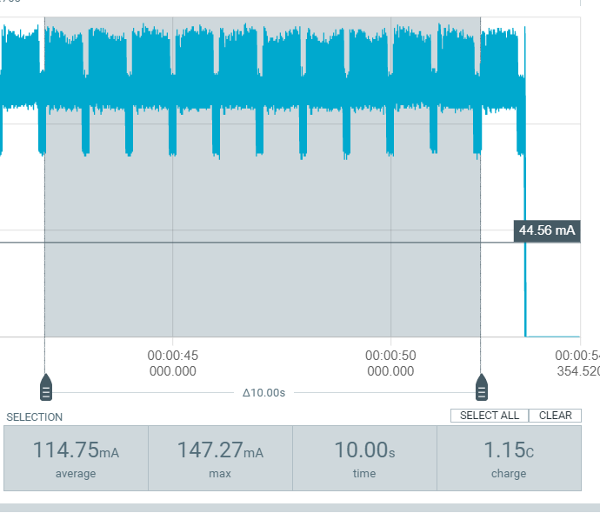

Lets do this 9 more times and see what we get

* 2nd run -> 114.45ma
* 3d run -> 114.50ma
* 4d run -> 114.36ma
* 5d run -> 114.54ma
* 6d run -> 114.84ma
* 7d run -> 114.78ma
* 8d run -> 114.70ma
* 9d run -> 114.86ma
* 10d run -> 115.04ma

Altogether, this gives an average mean consumption of 114.682ma with a standard deviation of 0.21347912.

### 10 crabs detected

I suspect that there is no real difference in power consumption between whether an inference detects a crab or not. So, to possibly save some time lets go straight to 10 crabs and see if this is the same as 0. To clarify: 10 crabs means that every second a picture gets taken with a crab in it, we do this 10 times.

The first run gives an average power consumption of 114.30ma, which is a little bit less than with 0 crabs. 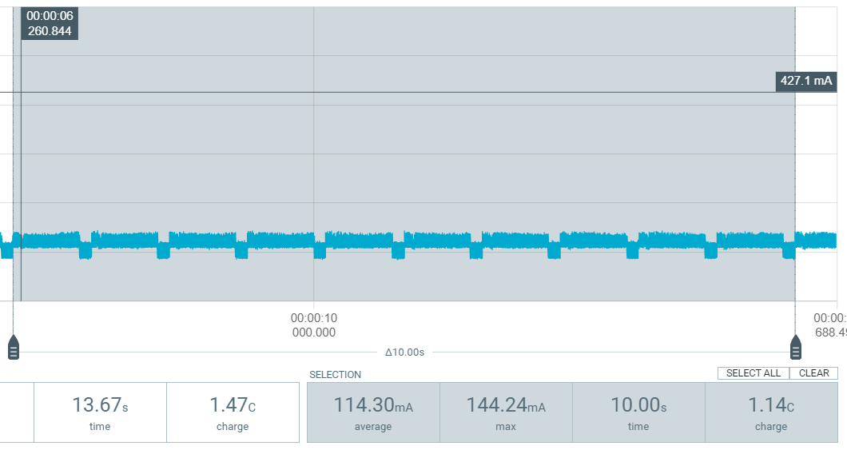

Lets run it 9 more times:

* 2 -> 114.51ma
* 3 -> 114.66ma
* 4 -> 114.73ma
* 5 -> 114.79ma
* 6 -> 114.71ma
* 7 -> 114.86ma
* 8 -> 114.91ma
* 9 -> 114.86ma
* 10 -> 114.97ma

This gives us an average of 114.73ma with a standard deviation of 0.20165977949672 which is close enough to the values of the test with 0 crabs detected to conclude that for his setup it does not matter if a crab is detected or not. Which is what I sort of expected because in both cases you take a picture and run the inference and whether a crab is detected or not is only the result of the inference. Do note that in this experiment the existence of a crab is simulated with a picture. I do not think that this is any different than detecting a real crab. -> I later tested with a real one just to make sure and the result is the same, detecting a crab or not when running an inference does not impact the power consumption for running that inference. -> Even later I tested this again for the final model and this remains true.

## With movement sensor

Now our esp32 is in deep sleep while our movement sensor is constantly on. Esp32 only wakes up when movement sensor detects movement and sends an interrupt. We do this again 10 times for each number of crabs between 0 and 10. We proved earlier that whether a crab is actually detected or not during a scan has no effect on the actual power consumption. So here we care about the number of scans and not the actual number of detected crabs since it does not matter.

### 0 scans

So this is bassicly just the power consumption of the sensor + esp32 in deepsleep over 10s. Values measuret => [49.54, 49.53, 51.85, 49.54, 49.57, 52.48, 52.22, 49.57, 49.56, 52.21]

This gives a mean of 50.607 ma and a standard deviation of 1.3706612353978 . This is of course less than without the movement sensor. But I want to know at exactly how many scans the tipping point lies. The value 50.607 ma is completely within my expectations.

### 1 scan in 10s

Example photo:

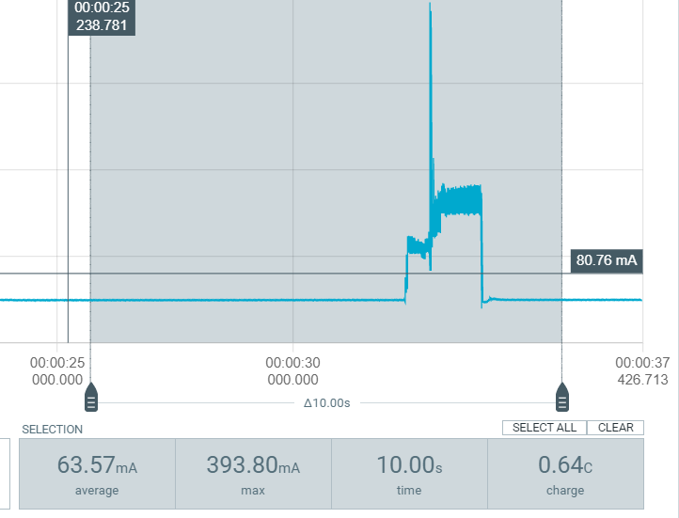

***Looking at this photo I just realized that this is not a fair comparison since it takes longer with the movement sensor to scan for crabs then without. I should later redo the measurements without the sensor and increase the time between pictures to match the time of the setup with the movement sensor (1.612s). With 1 scan taking longer than 1s it is also not possible to do 10 scans in 10s so, I will test from 0 to 5 scans in 10 seconds from now on.***

Measurements => [65.81, 65.95, 63.84, 63.57, 64.22, 66.13, 65.87, 65.95, 66.08, 65.84]

M => 65.326

S => 1.0166961744352

### 2 scans in 10s

Measurements => [79.85, 79.74, 79.43, 77.40, 77.92, 78.47, 78.43, 78.32, 78.40, 78.43]

M => 78.639

S => 0.79101130768712

### 3 scans in 10s

Measurements => [91.70, 91.71, 92.10, 91.78, 91.50, 91.15, 91.74, 91.86, 92.20, 91.83]

M => 91.757

S => 0.29261464989527

### 4 scans in 10s

Measurements => [106.09, 106.12, 106.07, 105.51, 105.64, 105.93, 106.16, 105.92, 105.95, 106.02]

M => 105.941

S => 0.21136855647581

### 5 scans in 10s

Measurements => [119.37, 118.92, 118.68, 118.84, 118.67, 118.74, 118.54, 118.41, 118.28, 118.67]

M => 118.712

S => 0.29913950665943

## Redoing without movement sensor

As previously stated the comparison was not fair since the setup with movement sensor took way longer for one detection. So lets redo the measurement. Luckily we can just change the picture and inference interval to match the rate of the other setup. We already proved that whether a scan actually detects a crab or not does not matter, so we can just do the measurement for 0 actual crabs detected

### 0 crabs V2

Measurements => [107.94, 108.22, 107.94, 107.64, 107.82, 107.9, 108.18, 107.59, 107.52, 107.95]

M => 107.87

S => 0.23380903889

## Experiment result

This graph tells me that as long as the setup with the movement sensor activates 4 times or less over a time period of 10s, it was indeed worth it current wise to use the movement sensor. Compared to a system that starts a new scan every 1.62s . Since the max scans in 10s then is 6.17, 4 or less does not seem like a bad result. The standard deviations are also in the graph but are basically invisible due to being so small.

# IR visibility

To see the crabs in the dark we use IR leds combined with a camera that can pick up on IR light. We need to make sure that our camera has enough light to see the crabs. All tests here are with the new 850nm LEDs. The setup I just with the 940nm burned out due to a bad connection. But to give an idea of how bad the visibility was I will put an old picture here:

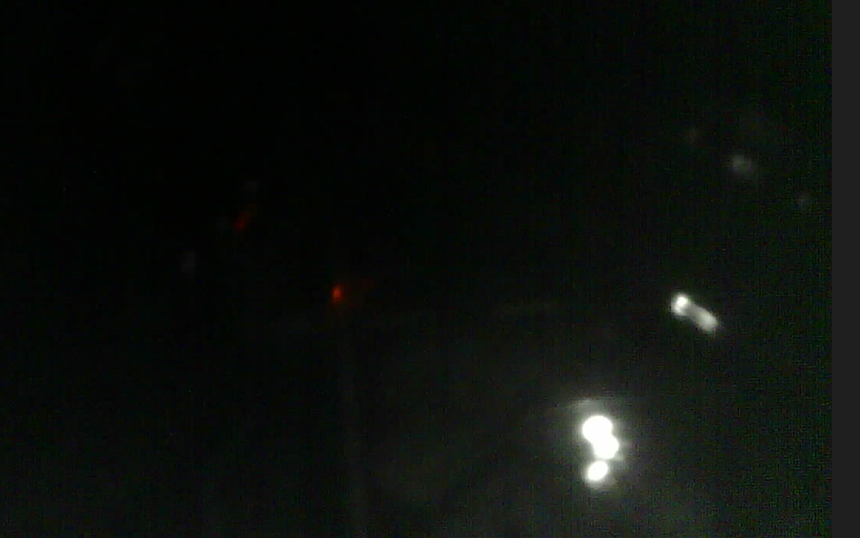

No visibility at all, only indication that the leds were even on is the small white dot. Since the leds in that setup broke and the fact that this is a very old picture for which I do not have a power reading I have no way to know that maybe the LED’s were just underpowered. But I read many sources online that say that 850nm is better anyway.

## 4 leds at 250 ma total

Leds where placed in a square next to the camera.

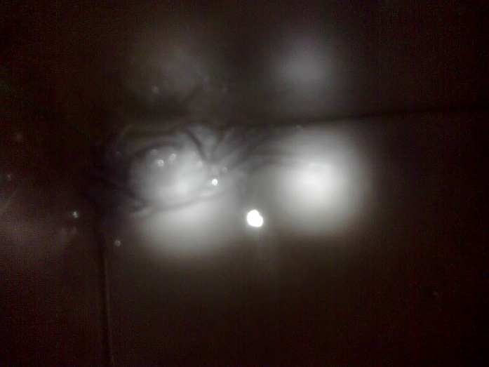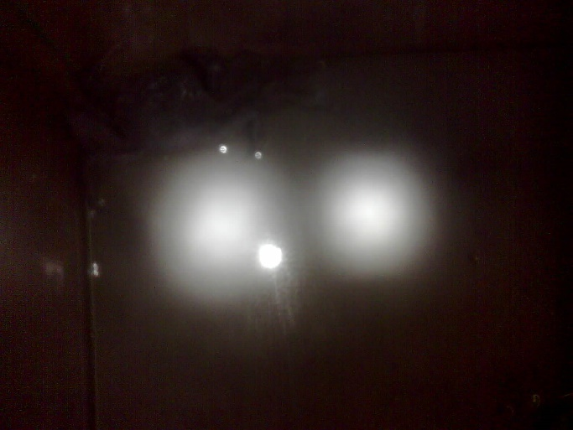

As shown in the pictures above the leds are verry focused. Causing only a small section in the middle of the picture to be visible.

## 8 leds at 500 ma total

This time 2 leds are placed at each side of the camera. Forming a square around the camera.

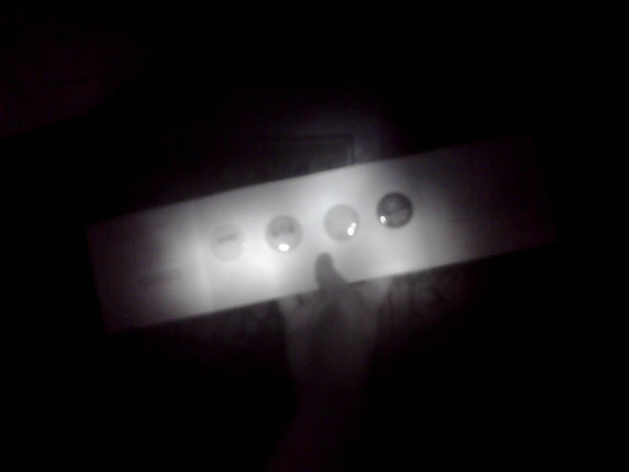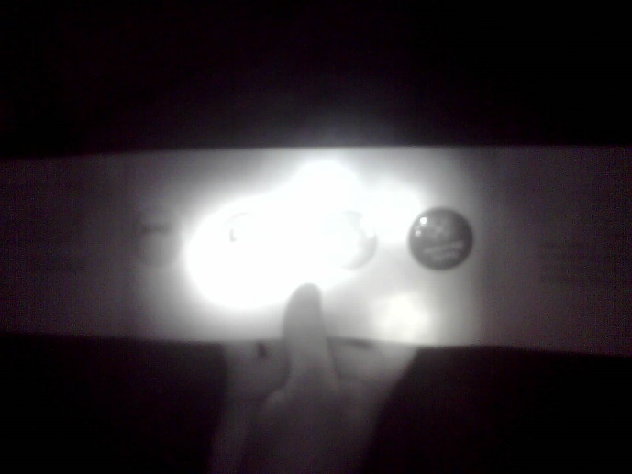

As shown on the picture on the left the visible area is now a bit bigger. But on the picture on the right we see that because the leds are so focused we get a burning point of bright light. This obstruct our vision. The Right picture does not have this because it is taken from further away. The setup on the right is already more viable than the setup with 4 leds. But we can not guarantee that we will always have enough space between the camera and the crabs to make this work. Also, we still see less than half of our picture.

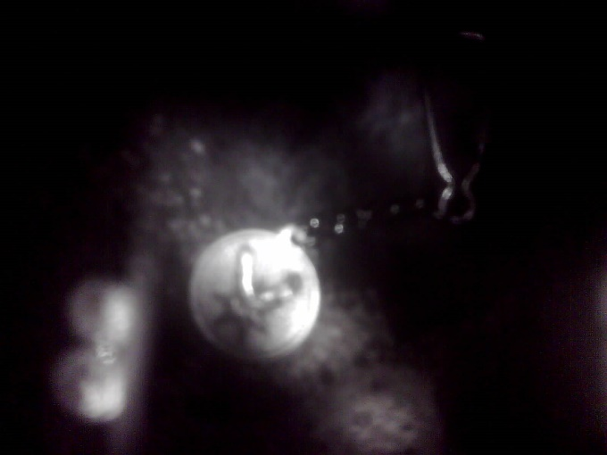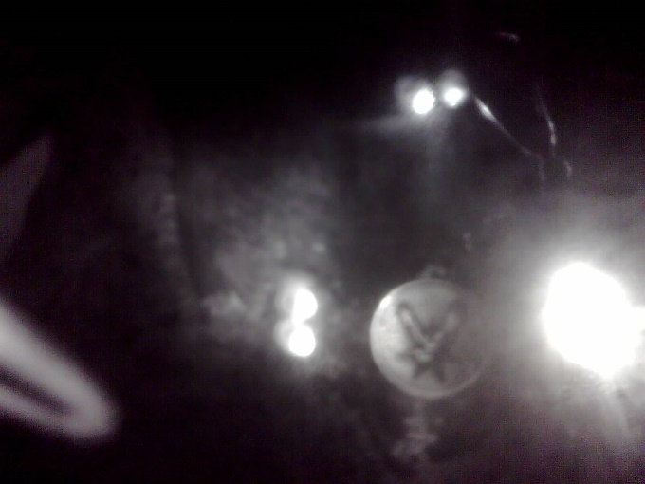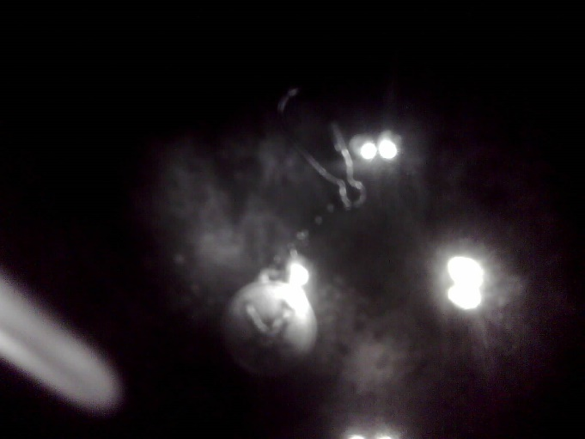

The three pictures above are of an object submerged in about 30 cm of water. The visibility in these three pictures is less than ideal, mainly due to the LEDs being to focused.

We can try to diffuse the light by putting our camera and leds in an opaque plastic container. 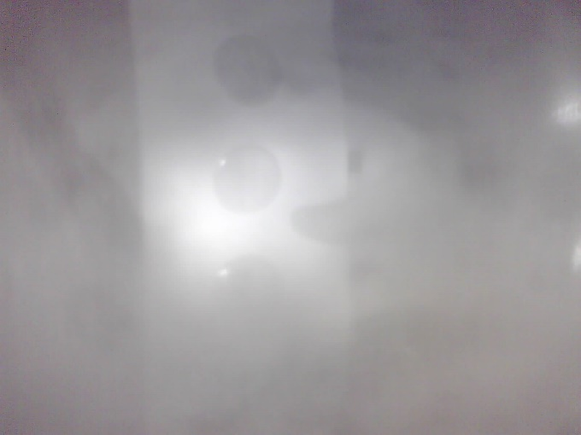

As we can see in the picture above this widens the area that is covered by the light of the LEDs. However, the image is so hazy that it is barely usable.

## Diffusing our leds with sandpaper.

We can try to turn our focused leds into diffuse leds by grinding them with sandpaper.

Control images:

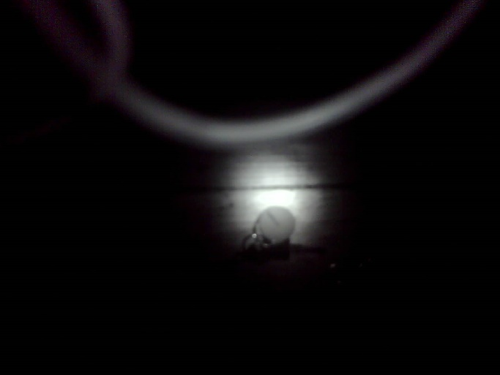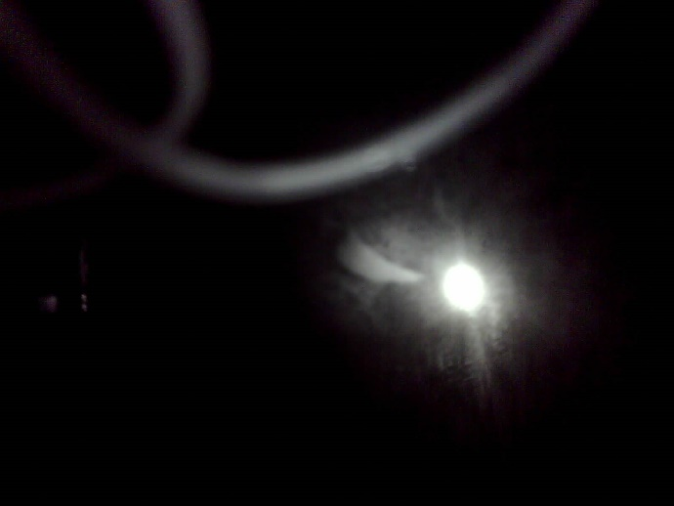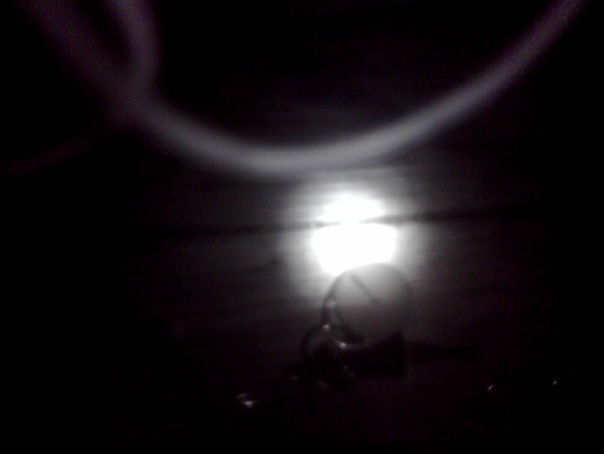

The first image on the left shows 2 leds at 150 ma total. The one below that one the same but this time the camera is closer to the object. Image on the right the same thing but with water. I only use 2 leds for now because I don’t want to start sanding down all my leds if I’m not sure yet that it will actually be better. So these are control images. The threads can be ignored by the way. They are there because this is a test setup.

Sanded down images:

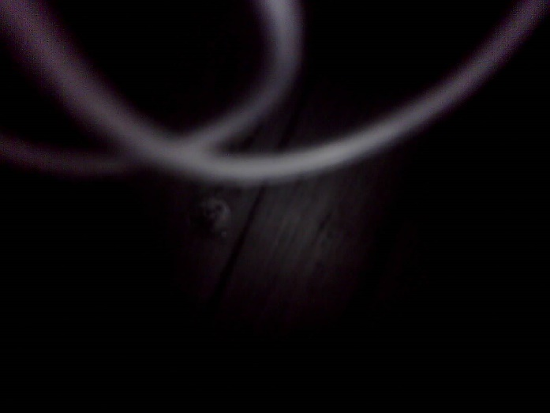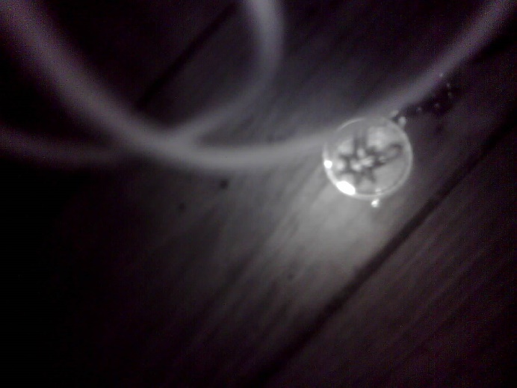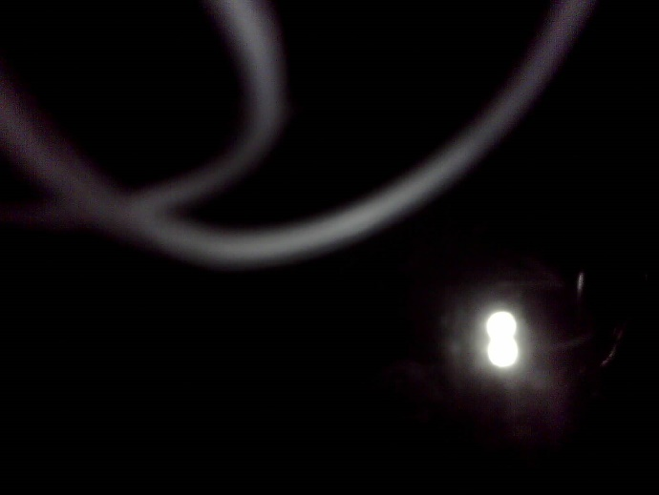

These four images show the result after sanding down the 2 leds. The first image is taken from farther away. The second from a little closer and the last from a bit closer than the second. This is honestly a very good result I think. It showcases that we have traded some range for a wider angle. The actual distance between the crabs and the camera will probably be like the second or third image. In the 2nd and 3rd image about half of the image is clearly visible. There is no more super bright burning point. The object is decently clear. This is a good result, because keep in mind that this is only 2 leds on one side of the camera. With 8 leds around the camera the visibility will probably be even better. Unfortunately the fourth picture shows us that when looking at an object in about 30 cm of water we still don’t see much.

## 8 LEDs at 620 mA in water

In the actual world this setup will be used to detect crabs underwater, so it is important that our leds also provide visibility under a few centimetres of water. Which so far in al the previous experiment has been less than ideal. In the previous experiment we also discovered that sanding down our leds is clearly a good idea. But when we look at the picture in the water the result is less certain. Probably because a focused light beam can penetrate further into the water. I don’t really dare to sand down the 8 leds since I have no replacement for them if this turns out to be a bad idea in water. I can try to recreate the same effect by covering them in some tape or using an opaque container like in an earlier experiment. Earlier we saw that an opaque container was not a good idea because the picture becomes to hazy, but we only tested this outside of the water.

You will also notice that now we have 620 mA instead of 500 mA. I designed the circuit to draw around 640 mA but I did not take into account small resistances created in the circuit. The worst offender was a breadboard at the start of the circuit. Because of the fit of the wire in the breadboard hole some resistance is created. This is not that much but since I only use a resistance of 44 ohm (originally 39 ohm but I didn’t have those) only a small added resistance in series with the rest of the circuit can steal some voltage. Less voltage over the 44 ohm resistor means that less current is drawn trough the LED. So by simply removing the breadboard I can increase the current drawn and therefore also the light intensity. It is still not perfect but it’s a lot closer to what I calculated. Of course we actually want to consume less current but visibility is something we really cant compromise on. Doing so would tank the accuracy making the system useless. I just realise I never gave a picture of the circuit I’m using so I will show it in the picture below:

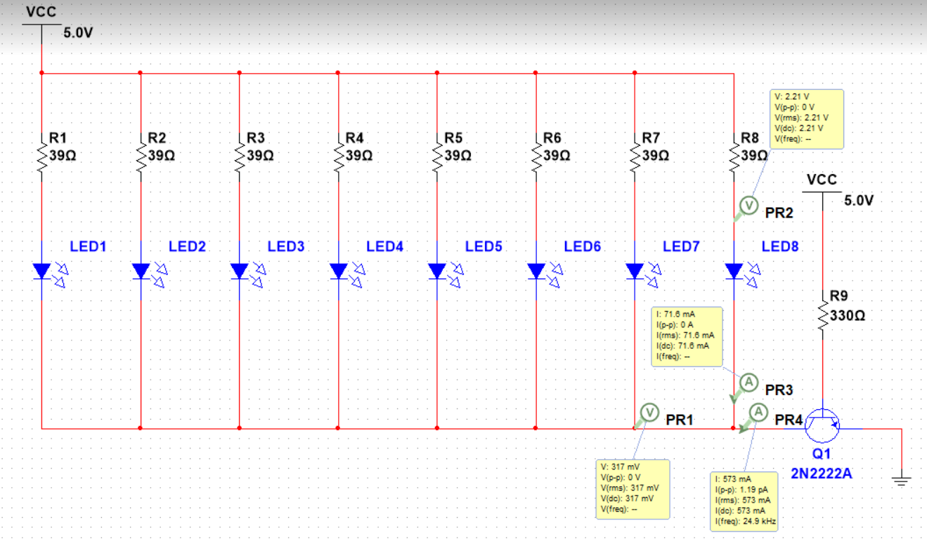

Note that the circuit shows a total current of 573 mA but this is because it uses the wrong leds the actual leds only take 1.5v over them instead of 1.9v. The actual circuit also uses 44 ohm for the resistors instead of 39. So, ignore those yellow boxes. Calculated ((5-1.5)/44)*8 = a total of 636.36363… mA expected. The actual reading of around 620 mA is because we only measure a total of around 4.9 v over the circuit most likely because of a remaining small unintentional resistance somewhere.

With that out of the way we can go back to our pictures. In previous experiments we already saw that pointing the camera at the water and taking pictures does sort of work but without diffusing the light of the LEDs this suffers the same problems as using them in a dry environment. This being that they are too focused. When not extremely close to the water surface the reflection of the leds also hits the lens, creating further obstruction in the image. With the sandpaper experiment we saw that the diffusion works great without water but seems to fail to penetrate water when pointed at it. The most likely explanation for this is that due to refraction and reflection when hitting the water the already scattered light rays from the diffused LED’s are scattered too much. The same probably happens with the none diffused LED’s but because they are so focused, enough light rays manage to enter without being reflected and the light rays then refract in more or less the same direction. Thus staying together. But I’m not a physicist, and the actual reason is not as important as long as I can find a solution. For now I will assume that what I just explained is indeed what’s happening and I will try to find a solution accordingly.

Keeping my assumption of the previous paragraph in mind a solution could be to bring the light source closer to the object. I want to do this by putting the camera in a plastic tray that breaks the water surface and can be submerged as needed. Also putting the light below the water level will probably reflect some light back into the water. I think breaking the water surface and thus putting the camera below the water surface is a good idea regardless. Because in the real world the water surface contains floating objects and maybe some foam or white water in stronger currents. Being able to avoid the visual obstruction those things pose is a win anyway.

### Breaking waterline clear tray 8 LED’s at 620 mA

So the first setup I want to try is to simply break the waterline and see what happens. Our camera and LED’s are put in a clear tray. The tray just breaks the waterline, the distance to the surface is about 25 cm. My prediction is that this will suffer from the burning points problem again. But probably a little less because even a clear tray probably scatters the light a bit, which is amplified by the refraction once the light hits the water.



The left photo shows an object submerged in water with the camera and LED’s breaking the water surface. The right photo shows the same but now the camera and LED’s in a clear tray are not breaking the water surface. The difference is obvious. Even though we still have a faint burning point and only half the picture is visible we do now know that breaking the waterline is indeed much better even when we ignore other benefits (like avoiding floating objects).

### Breaking waterline opaque tray 8 LED’s at 620 mA

Now lets diffuse the LED’s by putting them in an opaque container instead of a clear one. We already tried this outside of the water but the image was too hazy to be really useful.



Now the whole picture is lit. And vision is probably good enough. Perfect! Although I must admit that I don’t really know why the image is not that hazy now. I can imagine the image being hazy because some light hitting the container gets bounced back directly into the container giving the same effect as taking a picture when the sun is shining at your lens. But even if that’s the reason I still cannot explain why that’s not the case when breaking the waterline. But I feel like even though knowing the reason would be nice it is not that important and I should not waste much time on it if I still have other stuff to do.

## Breaking waterline clear glass 8 diffused LEDs at 620ma (FINAL)

Although it seemed like the previous solution was good enough there was a flaw with that setup. Since I can not legally take any of those crabs home I used the first random object withing sight as a substitute. The object I used is metal and thus is somewhat reflective. The crabs are not. The setup with the opaque tray still works best out of al the other ones on the crabs but the result is a bit blurry. Since I already gathered enough pictures I decided to take the risk and lightly sand of all 8 of my LEDs. This combined with a clear glass container breaking the waterline with the camera touching the bottom of the glass gives the best results on actual crabs to date. Below 2 pictures comparing visibility with the opaque tray on the left with the clear glass lightly sanded on the right:

 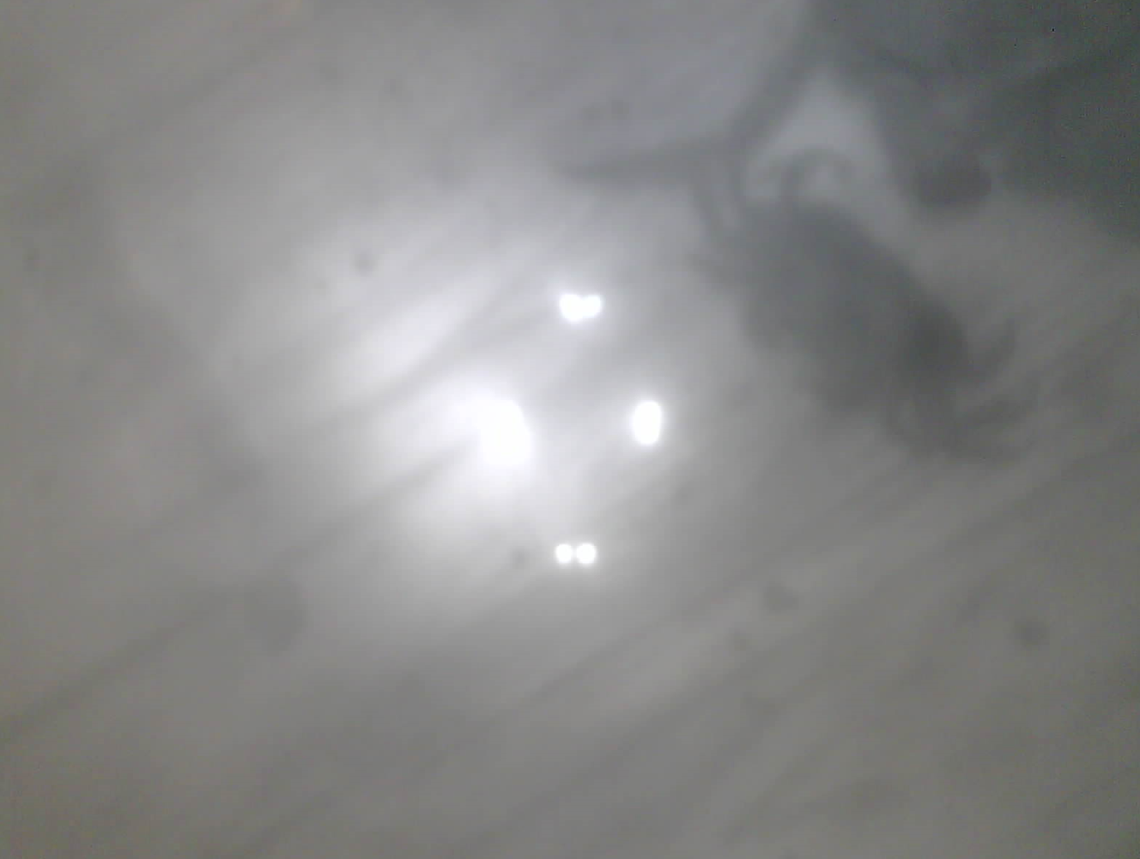

So this is the configuration I ultimately went with for the final iteration of the setup. I also used this way to take pictures for the final model.

# Tracking

## Altering current modus operandi to accommodate tracking

A huge drawback of taking pictures instead of video becomes clear when we start thinking about tracking. All the the tracking methods I found online and in papers assume that we want to track objects trough video. We chose to take pictures to save on power consumption. Now when thinking about it a series of pictures is the same as a video with low framerate. So, nothing is lost yet. We can alter our original code to take a picture when movement is detected. Then running the inference like we normally would. But then we can instantly take another picture when a crab was found in the previous picture. Run the inference again and take a new picture when a crab was found and so on. So, unlike the original system we don’t always go into deep sleep after every picture waiting for a new movement, with the new code we would only go into deep sleep after a picture with no crab in it was taken. A series of pictures essentially gives us a low frame rate video on which we can do our tracking. After a picture with no crab we go back in deep sleep and our system now knows that this is the end of our “video” and that it can discard its tracking information. To decide which crabs to count and which not we can say that every crab that disappears to the right side of our field of vision is counted. Or when the “video” stops if it is on the right side of the picture it can be counted as having crossed the imaginary line. Of course, a crab can always walk back and forth out and in vision but I don’t think there is much we can do to catch this. This would require us to identify the crabs individually instead of just their location. Which maybe can be doable on a bigger system with perfect lightning but not on our system. A huge disadvantage here is that we are obviously going to be using a lot more power since the time between pictures is going to be much lower and the system is not always going into deep sleep after every picture.

After discovering that the movement sensor did not work the movement sensor was replaced with polling. The movement sensor activation + waking up esp32 + image + inference + tracking took about 1.62 seconds. Of which only about 850 ms were spent on image + inference + tracking. So we can get roughly the same accuracy if we were to use an interval of around 800 ms (including wakeup time) instead of the movement sensor. It will obviously consume a lot more but still less than continuously running. Not that it matters for tracking if the final FPS is about the same. But I thought I should mention this here to avoid confusion.

## Centroid tracking (FINAL)

For tracking I have chosen to try the centroid tracking algorithm. This is a very basic algorithm based on the Euclidean distance between objects. It is the basis for many more advanced tracking algorithms. The reason I have chosen this, is because it is simple to implement. It works with centroids which is perfect since our detection model already outputs centroids. The way it works makes it so that it can be viable even on videos with low frame rate like in our case.

The working of centroid tracking for our use case:

1. Detect movement (This step was later taken out)
2. Take picture
3. Detect crabs and store their coordinates.
4. Take new picture, detect crabs, compare new crab coordinates to old ones by calculating Euclidian distance between each set of old and new coordinates. Old and new coordinates with the shortest Euclidian distance between them can be assumed to be the same object. But every old object can only be mapped to one new object. (known as the job assignment problem) Extra coordinates can be assumed to be new objects. Objects can of course also wander out of our field of vision, then they are no longer tracked.
5. The new coordinates now get stored instead of the old ones and essentially become the old ones for further operations.
6. Objects that disappear after last being on the right side (the middle is at x = 43) of the field of vision can be assumed to have crossed an imaginary line and can be counted.
7. Repeat steps 4, 5 and 6 until no crabs are detected in step 2. Then go into deep sleep.

This algorithm is very simple to understand and to implement. It does come with some major drawbacks. If two object cross each other they can be confused, but this is a problem in the detection with FOMO anyway. Remember that FOMO counts two objects in the same grid as being one object anyway. This does not make this fault ok, but it also does not make things worse. As previously stated, we also cannot handle crabs leaving the field of vision and then coming back. But this is pretty difficult to do anyway and I do not believe the paper before this could do that. The last big issue is that when an old crab leaves in the same frame that a new crab enters, the old one will not be counted. Because the system does not see a crab leaving and coming but sees the same crabs staying, because other than their position the system has no way to identify the crabs.

## The job assignment problem

The job assignment problem is a problem in which there are N workers who each must complete one of N jobs. But the time it takes for a worker to finish a job varies from worker to worker. It is our goal to minimize the total amount of time that is being worked by all the workers combined. In our application the workers are old crab locations, and the jobs are new crab locations. Instead of times we have distances between points. In our case it can also happen that there are more workers or old crabs then there are jobs and it can also happen that there are more jobs or new crabs than workers. The correct way to solve this problem correctly a 100% of the time is by using an algorithm known as “the Hungarian algorithm” which I wont explain because I do not understand It myself. The important point is that it is too complex to run on my little esp32. And in cases where the number of old crabs is low we are better of brute forcing the calculations to get the best old to new crab mapping. Brute forcing the calculations requires us to compute every possible combination of mappings. Leading to a time constant of O(N!) which can easily become insanely high at larger values for N. N would be the number of old crabs by the way. We don’t want to lose to much time on this problem because that would lower our FPS and thus our tracking accuracy. I ended up using a branch and bound algorithm that can solve this problem with a time complexity of O(M*N) with M new crabs and N old crabs.

## Implementing tracking / counting with branch and bound

(All actual code can be found on github)

I got the code I used to implement the branch and bound algorithm from: <https://www.geeksforgeeks.org/job-assignment-problem-using-branch-and-bound/> I basically copied the code and changed a few things so it would run on the esp32. I wrote some code to generate a 2d matrix containing the Euclidian distance between each possible pair of old and new crabs. To catch the adding or leaving of crabs I made it so that the 2d matrix does not have to be a square. I tell the system the dimensions of the matrix in advance with the oldCrabCount and crabCount variables. I then feed the matrix to the branch and bound algorithm which returns me with the last node of the optimal path. By following this node upwards by always looking at its parent until there no longer is a parent we find the optimal assignment. Any new crab that can not be matched to an old one is counted if the last spotted x coordinate of its centroid was larger than 43. The total count of crabs is kept in EEPROM memory so that it persists trough reboot and deep sleep cycles.

### How and why does branch and bound work?

The branch and bound algorithm works by starting from a root node. Then calculate the cost for all the nodes it can access beneath its current node. It will move to the node with the lowest cost. It will repeat these steps until there is no deeper layer it can explore. When it arrives at the final layer we have our optimal distribution. There are as many layers as there are “workers” in our problem. The cost for associated with each node is the values of the previously assigned jobs combined with the lowest combination of values from lower layers given that the current job is given to the current worker. A node can be seen as a combination of a worker and a job. An already used job can never be assigned to another worker. Lets look at it step by step.

1. Start with a 2d matrix with each column being a job and each row being a worker. For each combination of job and worker we have a value. To illustrate: 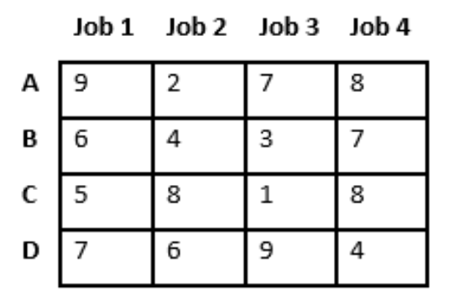
2. From the root node we want to branch out to layer A. Before we move to this layer we want to calculate the cost for each possible node of this layer. A node is a combination of a worker and a job. We calculate these costs by for each node of the A layer calculating the cost by going down layer by layer always selecting the lowest value at each layer without using the same job twice. Branch and bound is basicly a more efficient way of brute forcing. Illustrated on the previous grid the cost for each possible node would be: 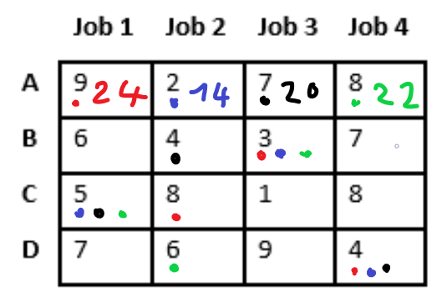

So giving job 2 to worker A is a good idea in this case.

1. We will now move to the node of job 2 and worker A on the A layer. Now that we are in this node we will never go back. Since we have a layer B beneath us we will calculate the cost for each possible node beneath us. Again going down layer by layer always picking the lowest value. This looks like this: 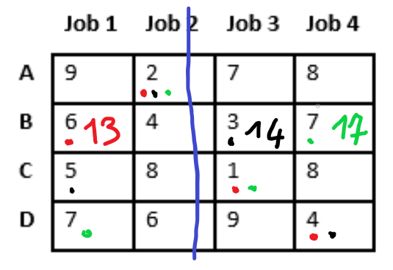
2. As you see we now found that using the node B1 is better than than B3, even if at first glance B3 has a lower value. Using B1 now even if it has a higher value now it will allow us to still use job 3 in the future. Which in this example has a very interesting 1 at C3. And as you see the values at job 1 are always pretty bad. We repeat the previous two steps until we arive at the bottom layer.
3. When we arrive at the bottom We have our final total minimal cost and our solution.

As you can see this is basically a fancier more efficient way of brute forcing. We save by not expanding every node. We will always arrive at a global optimal solution because we always fully expand every node in a deeper layer. We could possible save time by not expanding every deeper layer and taking a node as soon as the cost is better. This will give us a good solution but not the best. At the numbers I’m working with (I never expect more than 16 crabs in an image) it is probably fine to go with the implementation that always give the global optimal solution.

## Power consumption/FPS with movement sensor altered for tracking, see section tracking (deprecated)

Now that we have updated our code to accommodate our tracking needs our old power consumption readings are no longer valid. If our first image after movement detection (so after waking up) does not contain a crab the power readings remain the same as in earlier tests with the movement sensor (see experiment 1). If however, a crab is detected we will immediately take a new picture and run an inference. This will result in a higher power cost because we can now do more image/inference cycles in x seconds than with the previous setup. This is honestly just a trade-off between accuracy (tracker accuracy, higher FPS is better) and power consumption. After running a test we see that indeed starting up and taking the first picture and running the first inference takes about 1.62 seconds, the same as with our old code.

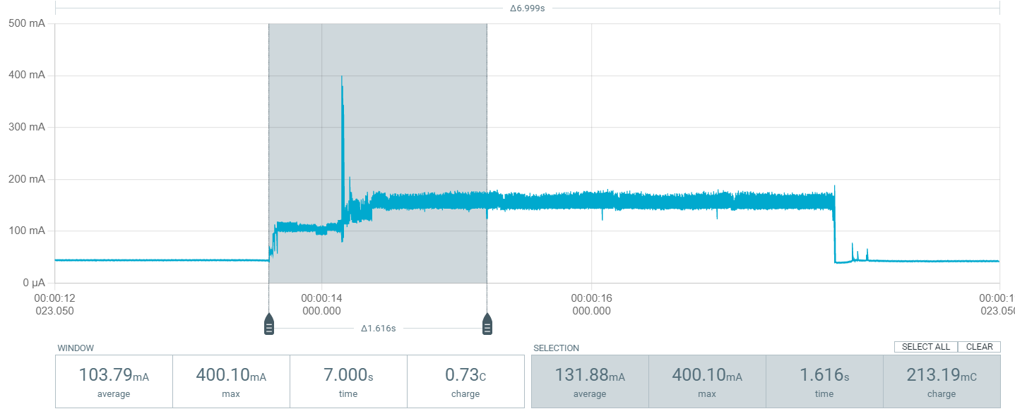

But every picture/inference cycle after that takes only about 0.85 seconds. Giving us a framerate of about 1.176 FPS after the first picture. Which is not very impressive, but at least better than the 0.617 FPS we would otherwise get on our tracking.

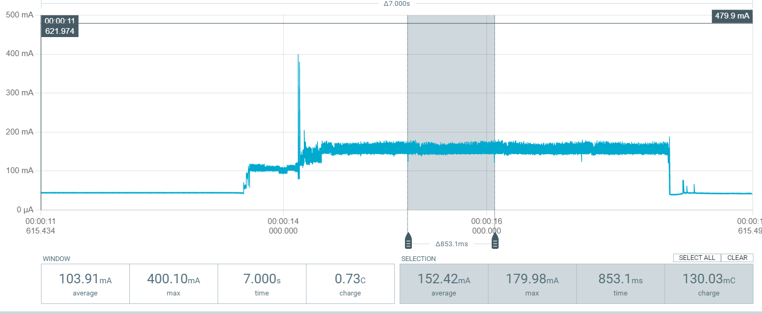

By the way, what is shown in these two pictures is the system waking up due to movement. Then taking a picture and detecting crabs three times. On the fourth picture no crab is detected and the system goes back to sleep.

I find it hard to compare this systems power consumption to the previous one. Because, lets say a crab walks trough our field of vision in 10s. Then our previous system will trigger 6.17 times (lets just assume that is possible). Our new system will trigger 9.86 times {((10-1.6)/0.85)+1}. Every trigger of our first system individually will consume more (they also take longer) than every cycle after the first of our new system. But over the 10s the new system will run more cycles and since the running of a cycle costs more power than waking up from deep sleep the new system will use more in those 10s. The problem is that now we can not plot our consumption on the graph of exp1. Because now it does matter whether crabs were actually detected or not. I guess we can plot the new system and the old systems power consumption together if instead of plotting the sensor triggers per 10s on the x-as we plot the amount of seconds the crab stays in vision on the x-as. This graph will show that the new system costs more power than the old. We can also annotate the timestamp of when a new picture is taken so that we also show that the new system has a higher resolution. The standard deviations on the previous measurement in exp1 were so small that I’m only going to do one or two measurements per situation. This is obviously not very correct of me but I’m running out of time. I will of course also mention this in the paper and double check when results are not as expected.

***NOTE: I was planning to do this but this is when I figured out that using the movement sensor does not work well.***

# Final model (FINAL)

To train the model we created an Edge Impulse project. Edge impulse makes it very easy to create your own models to run on constrained devices. I ended up training two models. One model is trained on a combination of light circumstances, different trays, different backgrounds and with random objects added. The second model was trained on images taken from a setup that always used a glass tray, always had the same background, always had the same external light source and the same background. I created a new edge impulse project for each model and selected object detection on the dashboard.

## Gathering training data

To get images to train our models I put 12 crabs in an aquarium. I covered half the aquarium floor with river gravel. I placed my setup in a tray breaking the water surface with the camera against the bottom of the tray. There was about 40 cm water in the aquarium. I wrote a piece of code that at first would take a picture each time movement was detected and store that picture on an sd card that was put inside the esp32-cam board (the board came with an sd card reader). After gathering enough pictures the pictures where uploaded to the edge impulse project. In the edge impulse data acquisition tool I then manually annotated the bounding boxes of crabs on the images. At about 720 pictures this was a lot of work (Around 430 for the first and around 290 for the second model ). Edge impulse makes labelling a bit easier by employing a yoloV5 tracking ai that tries to track labelled objects trough images. What was annoying is that this ai does not detect objects leaving the image so sometimes removing every label was quite annoying.

## Training the models

To design our impulse we selected an image data block. We resized the image from 1600x1200 to 96x96 (remember the middle of our image being x = 43 from the tracking section). For the resizing method I chose squashing. Resizing to the longest side and adding 0 values (black border) to pad would have been fine too. I did a short internet search and found that there probably is not much difference in performance. I just did not want to choose the resize to shortest option because in a lot of my training data the crabs are on the side of the picture and they would possible fall of then. After the image data block came an image block. This block converts the images to grey scale I found that this made the final model smaller in ram. Grey scale does also not cause a lot of information to be lost in our cases since most images are black and white due to the IR light anyway. Having a small model is really important since our esp32 has only 520 kb ram. After the image block comes an object detection block. This block uses FOMO MobileNetV2 0.35 to extract features. For both models I chose to run 60 cycles with a learning rate of 0.001. I also used data augmentation, an option that transforms training images during training so that more cycles can be ran on the same images without overfitting. After training the 2 models this are the predicted results :

Model 1 dirty data (everything mixed) -> F1 = 60,6%, peak ram = 239,1 Kb, flash = 72,5 Kb, inference time = 1.301 ms

Model 2 clean data -> F1 = 76.6%, peak ram = 239.1 Kb, flash = 72.5 Kb, inference time = 1.296 ms

I don’t know how reliable these numbers are since I already confirmed with my power profiler that the inference time is in fact less than 1 s. I tested it to make sure and inference time for model 2 (the one I use) is only 750 ms. The F1 scores are also not very promising to be honest. I guess 76.6% is sort of ok maybe?

Using the unoptimized float 32 over quantized int 8 increases the F1 score by about 5% for the 2nd model and by a whopping 15% for the first model! However this is not usable because it also increases the peak ram usage to 893.8 Kb for both models. Making it impossible to run on our 520 kB ram.

## Deploying the model

Deploying the model is very easy trough edge impulse. You can simply download the model as a C++ library. Or in my case as an Arduino library. There are a lot of deployment options. You download the zip and add it as a library in the Arduino IDE trough the add zip library option. Then simply include the library in your project. You can now run functions like the “run_classifier” function like in the picture below. (for full code see github, also disclaimer: most of this code is taken from examples provided by edge impulse and slightly altered to fit my needs. I did not invent all of this code myself)

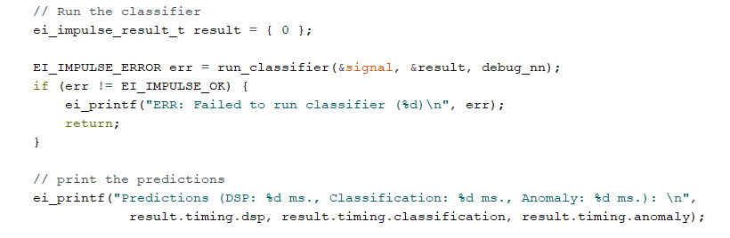

## Model accuracy

When training the model we got an F1 score but we cant blindly trust this score and should take some pictures and evaluate the models for ourselves. When putting pictures into edge impulse you can tell edge impulse to keep 20% of pictures separate to use as testing data later. You can also later add new pictures to the test data if you want to evaluate a model on a specific scenario.

### Model 1 dirty data accuracy

When testing this model with a variety of different data (different external light, background, objects etc, many crabs, no crabs) we get and accuracy of 69.32%. Do note, this accuracy is calculated by taking the percentage of training images that have an individual F1 score of 80% or higher. So a picture containing many crabs can still be considered a full success even if one of the crabs is not detected. On the other hand pictures containing for example 2 crabs with only one detected will count as a full fail to this metric. While evaluating the images individually I noticed that it does not seem that there are for example noticeably more false positives than false negatives. It does seem like the model seems to fail more on images containing other objects. It also seems that the model fails hard on images with gravel in the background. When only considering images that are 100% correct as correct we get an accuracy of around 62% (On a test set of 88 different images).

Model 1 public edge impulse repo -> <https://studio.edgeimpulse.com/public/231158/latest>

### Model 2 clean data accuracy

This model only uses “clean data” Which means the same external light, same background etc. I don’t think this is unrealistic since the counting system will be placed inside something anyway. The previous group already proposed a box like setup to reduce water turbidity. I don’t think it is farfetched to assume a container that can keep the conditions inside the trap more or less constant. Which will undoubtedly lead to better accuracy on the detection.

With that out of the way lets look at this models performance. Using the every F1 score equal to or higher than 80% is a full pass and every lower F1 score is full fail methodology we get an accuracy of 80.39%. This is a lot better than with model 1 but hardly surprising. The 100% F1 score only accuracy here is 66.66% (51 test images). A lot of images get an F1 score of 80% in this test set. This is quite disappointing since the 80% accuracy looked promising. Upon closer inspection it seems that a lot of the 80% F1 score images are caused by a crab that is detected to the side of the image. Surprisingly on closer inspection most of those detections are actually correct as well. I did not see those during labelling. This is caused by the fact that edge impulse makes the sides of an image you are labelling a bit darker to show what is inside a square resolution and what is outside. This makes it harder to see crabs in the darker parts of the pictures while labelling. Since I use squashing and not reseizing to the shortest axis to make my images square that darker area during labelling serves no purpose other than being annoying in my opinion. After counting how many of the 80% F1 score images are actually fully correct I get a full 100% accuracy of 70.59%. Below a picture of the result of model 2 on a single crab with some random objects added to show how the output looks. The output is a squashed 96x96 image, that why the quality is so bad.

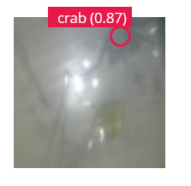

Model 2 public edge impulse repo -> <https://studio.edgeimpulse.com/public/231662/latest>

### Accuracy conclusion

To put the two model accuracies in perspective lets look at them from the perspective of tracking and counting which is the ultimate goal of the system. For the first model the rounded 60% full accuracy rate would mean every new inference we have a 40% chance to miss a crab or see one where there is none with this model. Since we have low FPS on our system counting is considered each inference. This would mean that each inference we have a 20% chance of counting one or more crabs that should not be counted. (If false positive -> can count crabs; if false negative -> can count crabs double or count crabs once when crabs should not be counted because disappears, next frame is back and tracked as new crabs; 20% not 40% since crabs only gets counted past the x = 43 line, ½ chance -> will mess up tracking but ultimately no effect on counting) For model 2 this number will be 15% following the same reasoning. This honestly is far from ideal and I had hoped for a better result, especially with the 2nd model. We can not always what we want I guess and a bad result is still a result I guess. The main culprit in these low numbers is the fact that images can be quite unclear due to bad lightning and the fact that crabs are also photographed on the side of the FOV. This causes only half or 1/3 of the crab to show up in the picture. Then the question is do we label this as a crab or not. I did, but in hindsight and for a future iteration it would be best to not do that so that the model only learns to recognize full crabs. We can enforce this in the final setup in the same way to force a constant background and external lightning situation. By designing our trap like a box containing the counting setup, protecting it from external factors. If we make this container about as wide as our cameras FOV we can ensure that only full crabs appear in the images. The use of a container to keep out external factors was also one of the conclusions of the paper before me so I guess that finding still stands. I’m tempted to train a new model now with only full crabs and the same background so I can at least boast an actual decent accuracy somewhere and I can show that the use of such a container will improve accuracy. I however don’t have time to do this so this is definitely some possible future work.

# Final power consumption (FINAL)

Unfortunately, due to discovering that using the movement sensor is not viable I once again have to change the way the system activates. I think I’m going to keep it simple here. I will start by once again getting a baseline reading of the system being continuously on and then try to experiment with some deep sleep intervals. Luckily previous conclusions that can make these readings faster and easier still stand. To recap, we found that whether a crab is or is not detected during an inference has no impact on the run time or power consumption of that inference. We also found that when power profiling the standard deviation was so small that we can justify doing every reading only once or twice. See chapter “Power consumption movement sensor vs no movement sensor experiment”. Unlike in other power profiling experiments before I will now be profiling the whole setup. So, the IR flash the taking of the picture the running of the inference (with final model), the running of the tracking and the counting. Finally giving us a true power profiling of the whole system

## Baseline

Power profiling on setup continuously taking pictures and running inference. LEDs are turned on right before taking picture and turned off immediately afterwards. The profile looks like the picture below:

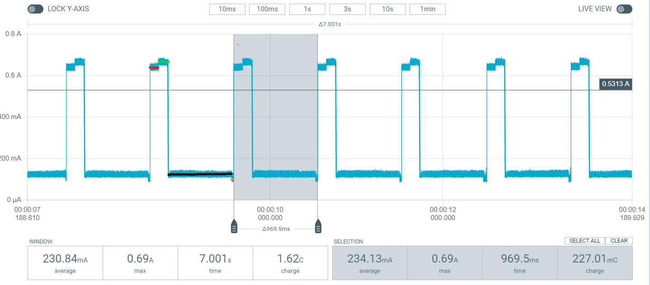

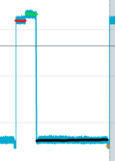

The red line is the LEDs starting up, they need some time to startup 100 ms seems to be the threshold. The green line is the LEDs being on + taking a picture. The black line is running some dsp on the image and the inference. The orange line is tracking + counting. In total we get an average current draw of 234.13 mA over 969.5 ms for the whole selected cycle. Due to the tracking part taking a bit longer when there are more old and new crabs to match there is a slight variation in time and average power. After measuring a few cycles with different numbers of detected crabs it seems that this difference is never more than one or 2 ms at worst and 1 or 2 mA at worst. Of course, at ridiculous numbers of old and new crabs this difference will be bigger. We can conclude when running our cycle continuously we use 234.13 mAh. With the LED warmup and tracking time added we get a little more than 1 FPS for our tracking.

## 1 s deep sleep interval

### No crabs detected

Since the use of our original movement sensor is no longer an option, we can try to get the power consumption down by using a polling interval of 1s. So, we wake up from deep sleep and take our first picture, then whether or not a crab is detected in that picture determines whether we stay awake and take another picture or go back to sleep. When a crab is detected we stay awake. We keep repeating the cycle of taking pictures running the inference and tracking continuously like the baseline until no crab is detected than we take a 1s deep sleep break. During moments where crabs are detected, our power consumption and FPS will be the same as the baseline. However this approach saves time when no actual crabs are detected. Because it does not make sense to continuously run the cycles if there are no crabs anyway. I chose 1s because that time is too short for most crabs to pass the camera without being spotted once, even when they start at just the right time. A power profile of this setup (again including everything included in the final setup) looks like this when no crabs are detected:

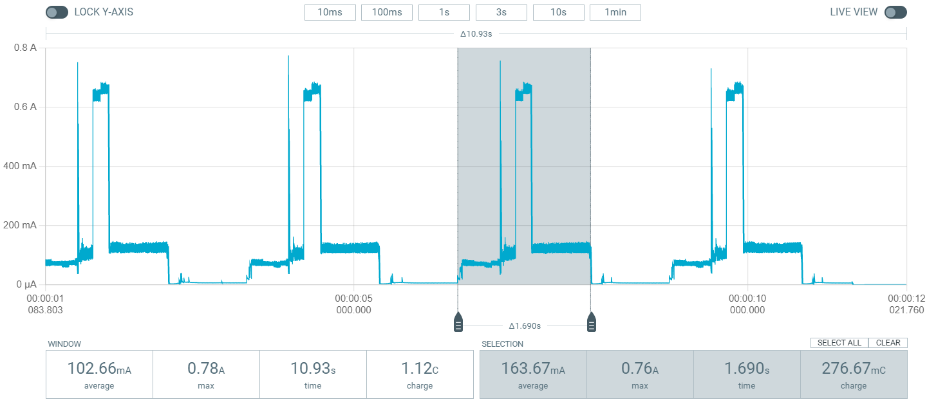

It seems for I a moment I forgot that waking up from deep sleep also takes time. I will alter the wakeup time in my code to make sure that the time between 2 consecutive pictures is never larger than 2s. :

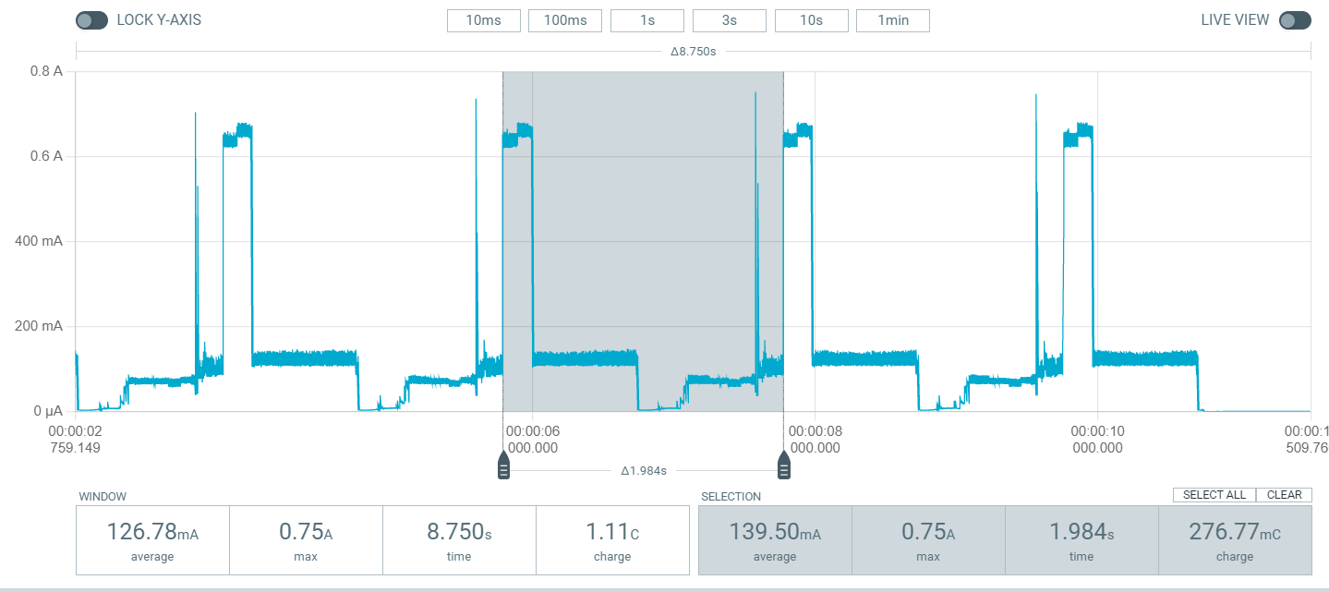

We get a consumption of 139.50 mAh. To put that into perspective say we have a 10000 mAh li-on battery that can be fully discharged. If we never encounter any crab this setup can run unattended for about 71 hours while the continuously on setup can only run for around 41 hours. The raspberry pi the previous students used could only run in idle for 14 hours on the same battery. We have an FPS of 0.5 while in this mode, until we detect a crab of course, then we go up to 1 FPS.

### 1 time crab detected

Let’s see what happens if a crab is detected. I previously proved that using a picture of a crab taken with the setup to trigger a detection is the same as seeing an actual crab. So I will be using pictures, since that is more convenient because I unfortunately legally cannot bring any crabs home. A power profile of the system with one crab detected looks like this:

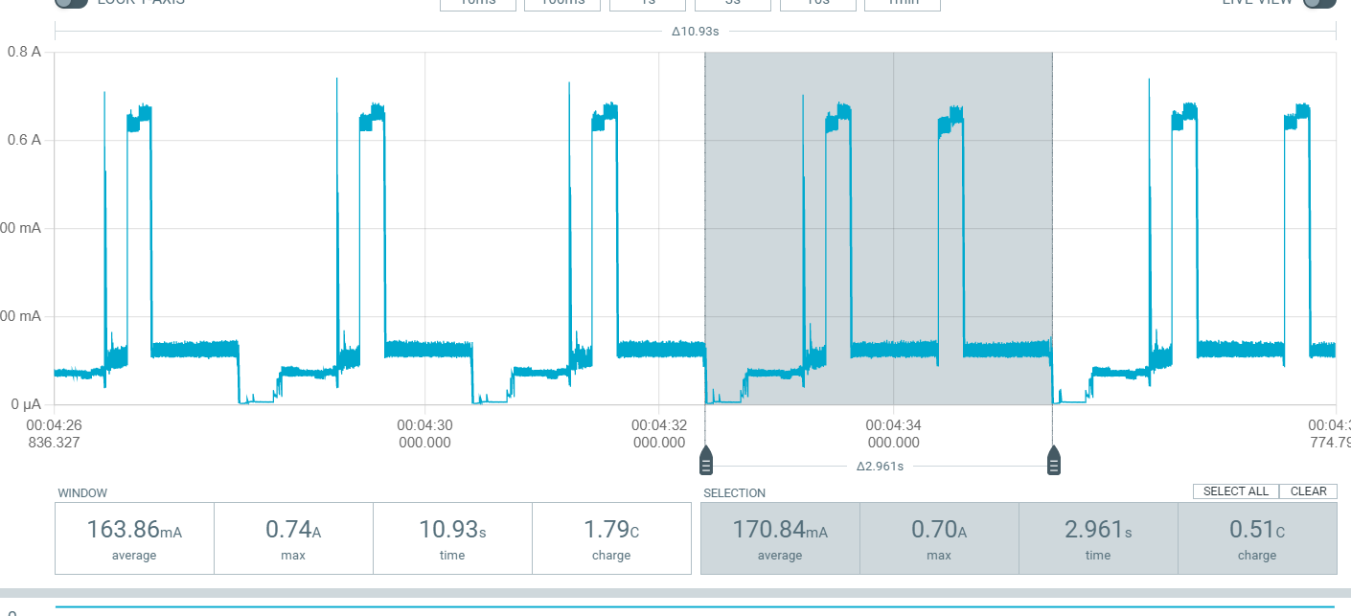

170.84 mAh

### 2 consecutive crab detections

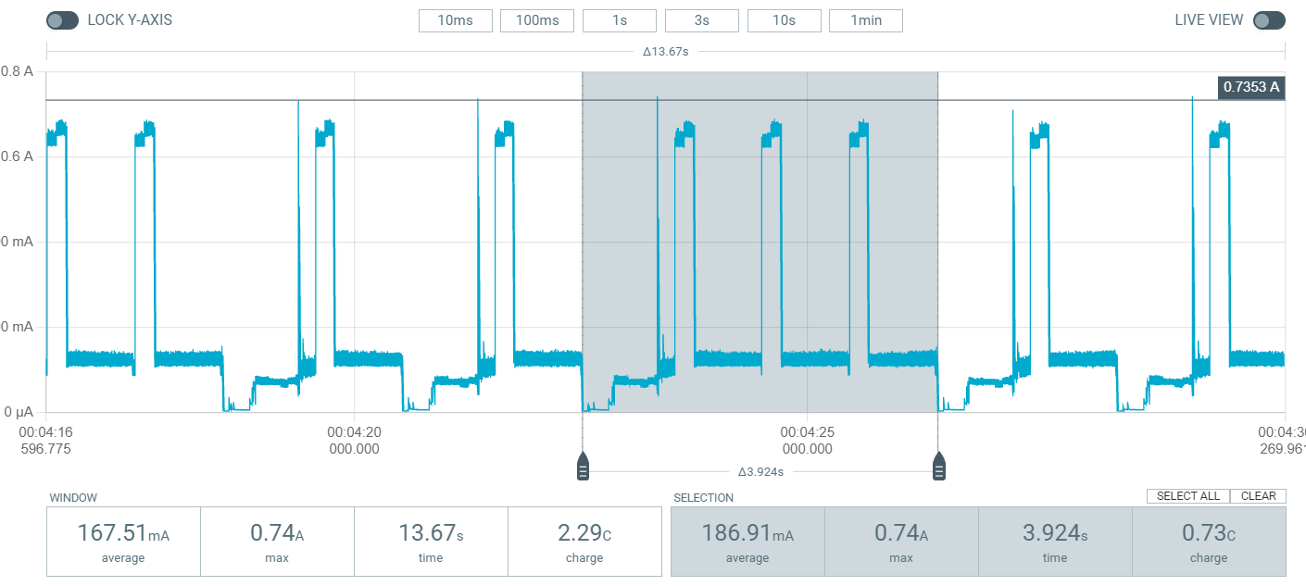

186.91 mAh

3 consecutive crab detections 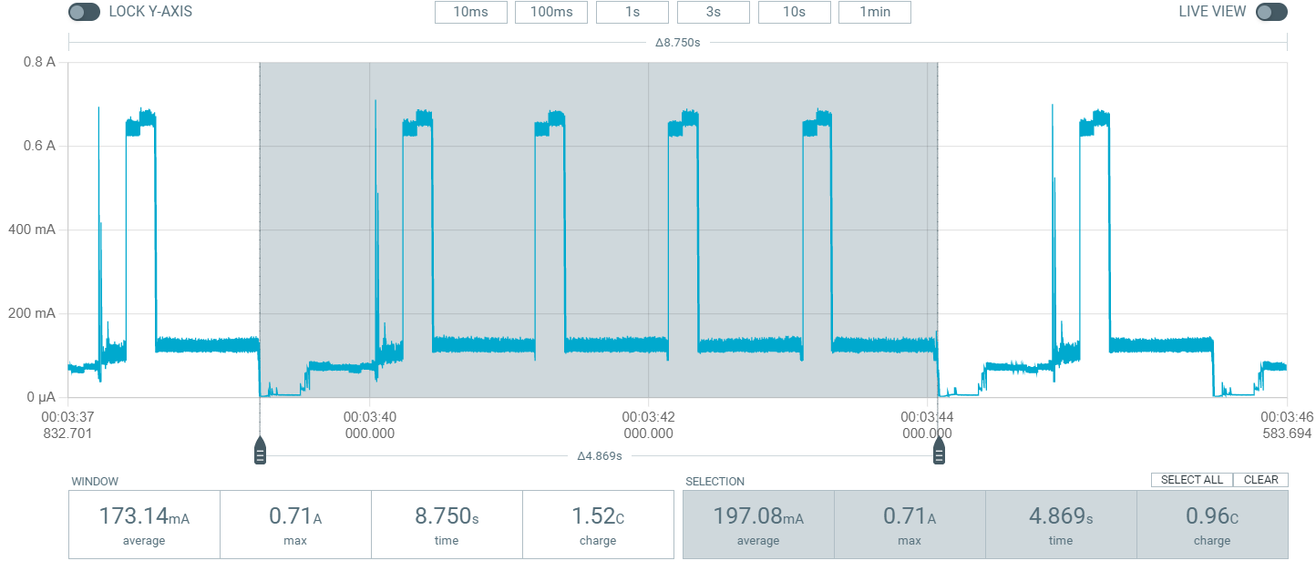

197.08 mAh

### 4 consecutive crab detections

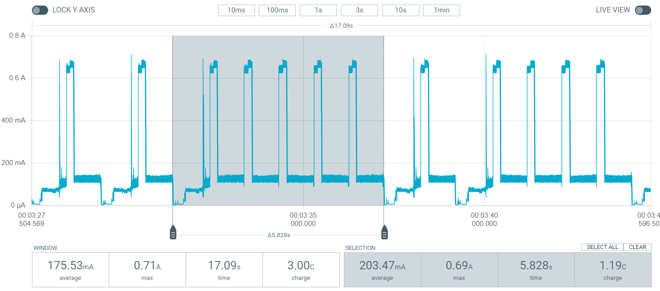

203.47 mAh

### 5 consecutive crab detections

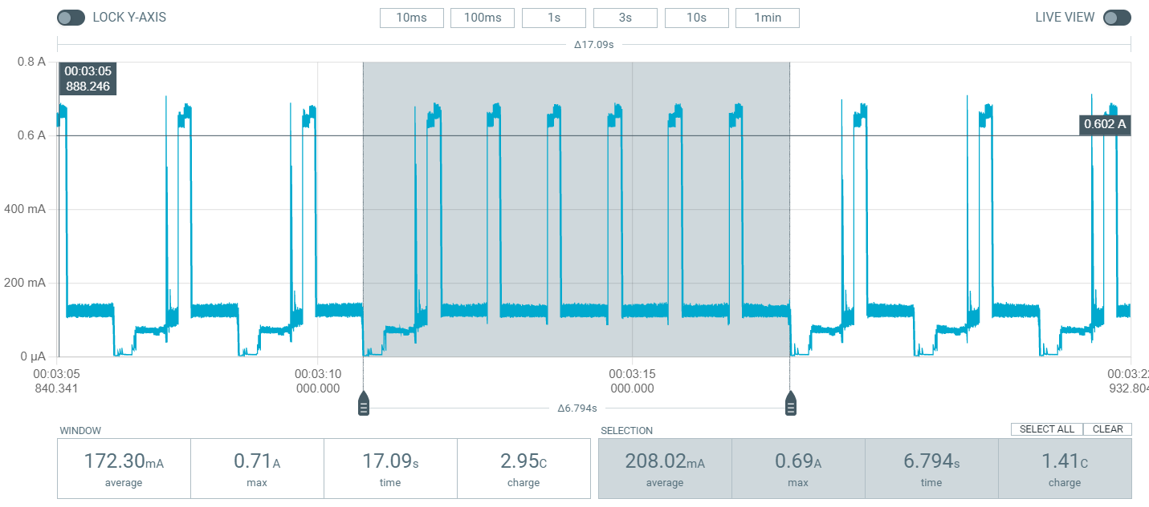

208.02 mAh

### 6 consecutive crab detections

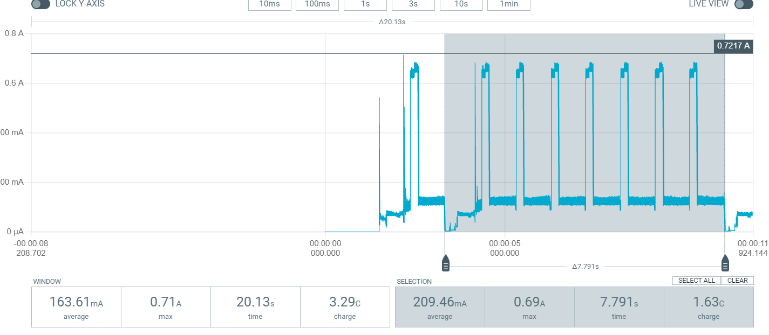

209.46 mAh

### 7 consecutive crab detections

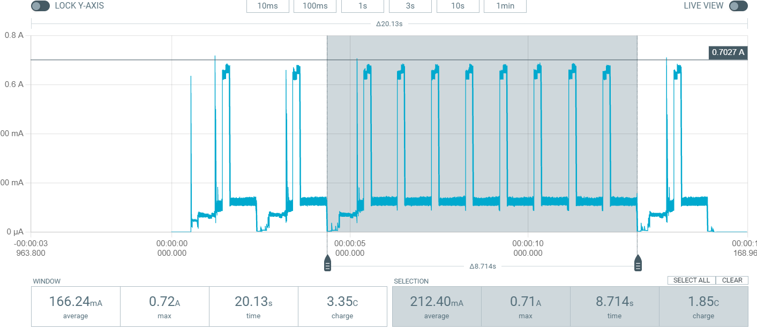

212.40 mAh

### 8 consecutive crab detections

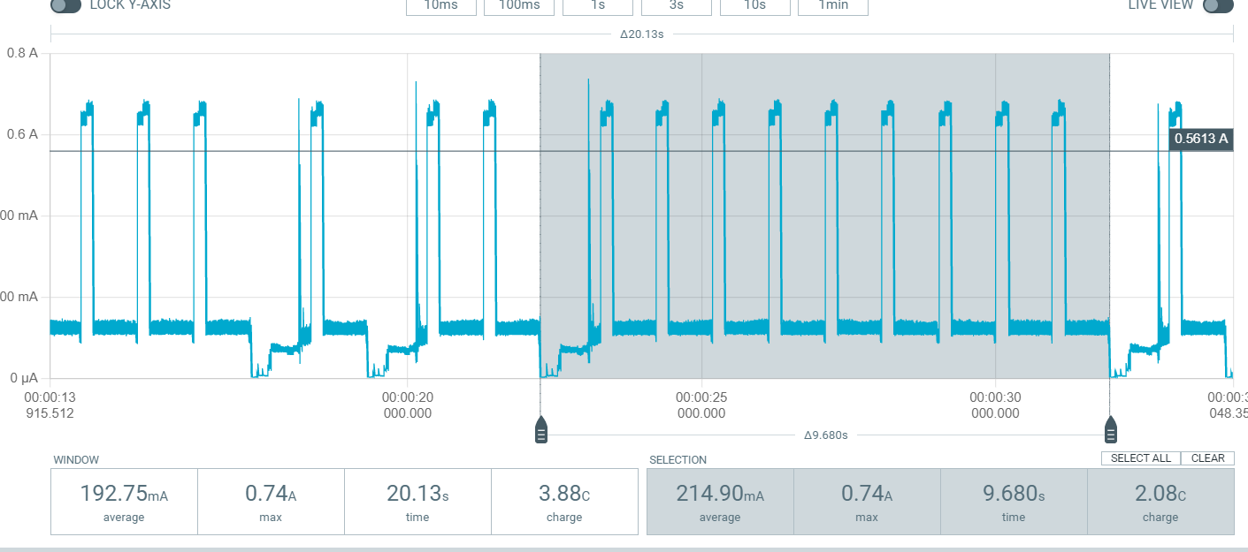

214.9 mAh

### 9 consecutive crab detections

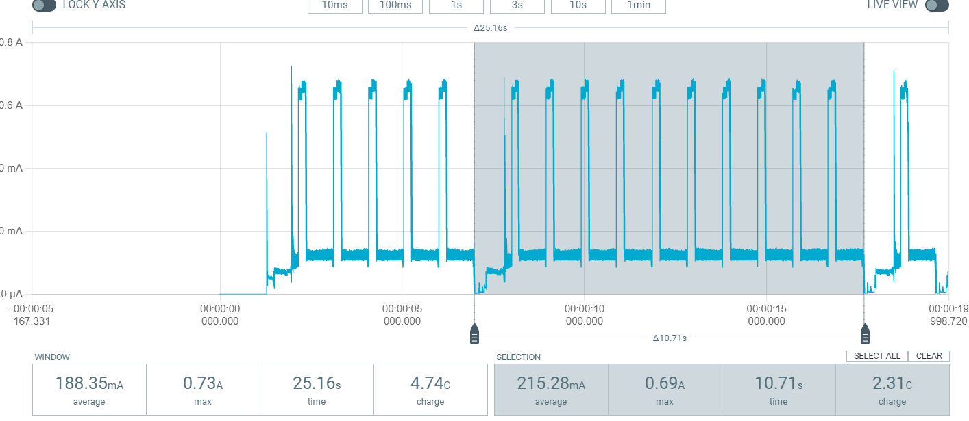

21.28 mAh

### Conclusion

Lets keep it at that I’m sure that with infinite consecutive detections the consumption of the one s polling algorithm will converge to the baseline reading. Let’s graph our results:

Our polling algorithm will never consume more than when we continuously run our system. So, power consumption wise this is never a bad Idea. Longer deep sleep times and thus lower overall consumption mean that there is a bigger window for a crab to accidentally pass without being noticed. The fact that our movement sensor does not work is really sad because with that we could achieve much lower power consumption than we currently do. I also feel like increasing the deep sleep time to show better results is being dishonest about my system. Because the FOV (field of vision) of my system is not big enough to guarantee that no crab will slip by while in deep sleep at higher deep sleep times. Future work would definitely include looking for a similar replacement for the microwave sensor.

# Final test and conclusion (FINAL)

I did a final test where I combined everything to confirm whether the isolated test results regarding power consumption and accuracy are still valid when combined. Below is a picture of the setup on which I tested.

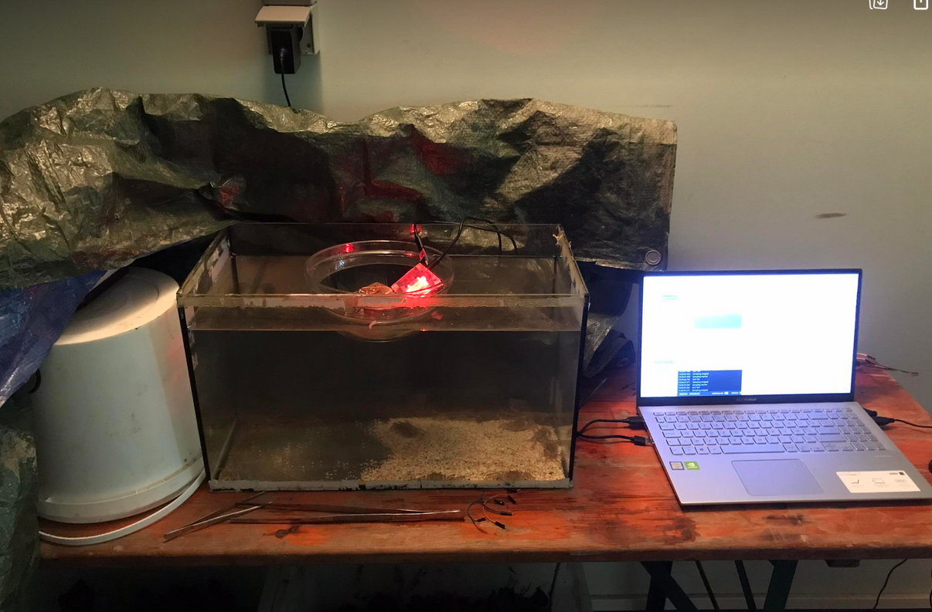 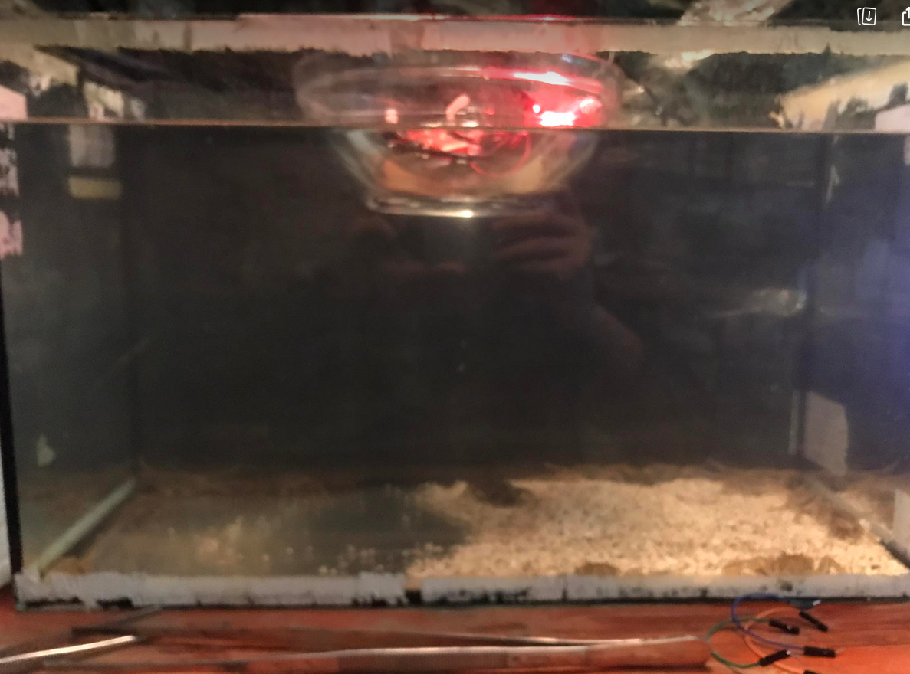

I looked at the logs of the esp32 board that were updating in real time to confirm whether a crab count was legit or not. While on the other side keeping an eye on the power profiler. A problem with my test setup was that the crabs prefer to hang out in the corners of the aquarium and don’t really like to move. So, I used a long stick to push them a bit and get them to appear in front of the camera. This might have caused them to move at speeds and in ways that they would normally not do. Another flaw in this setup is that there is no real incentive to not backtrack. The crabs do not have somewhere they want to go. Sure, I can move them with the stick but they did not seem afraid of it so they would not avoid it or try to get away from it. In a real scenario the crabs are probably migrating to one side of the river and have less incentive to just randomly walk back. I do not expect to see any wildly different results here than in my isolated tests, I just wanted to make sure that everything can work together. The power measurements are the same as in previous test as I expected them to be. The accuracy also does not seem to deviate much from the results I got in edge impulse, which is normal because both run the same model on the same type of picture.

## Conclusion

The accuracy result of this final test confirms my suspicion that my accuracy just isn’t high enough. I used the 2nd model and I arrived at a rough accuracy of around 75% (this is the 100% correct per picture needed accuracy, not the weird 80% correct per picture is enough to count as a pass accuracy that edge impulse uses.). This seems not great but still ok until you factor in the way the counting / tracking works and all of a sudden you are counting a lot of crabs that are not actually there. That being said, the counting / tracking works great even at around 1 FPS. I have never seen the branch and bound approach make a mistake. Which admittedly would be weird if it did. Another obvious success is the power consumption which is way lower than the original setup. Since the previous group did not really mention the power consumption of their full setup when running it’s hard to compare the 2. But even when we compare our setup with 234 mA at wort and 139 mA at best to the raspberry pi 4b’s idle consumption of 680 mA our setup still ends up on top. And that is comparing my whole setup against only the idle consumption of their platform, so not including the camera and massively powerful IR lights they used for which I could not find a power consumption online. Even though accuracy is lower than I would like there are some obvious ways to increase it like for example making sure only full crabs can appear in a picture and adding more or stronger IR lightning. I was also pleased by how easy it is to create a model and upload it on a cheap tiny microcontroller like the esp32. That brings us to another big advantage of this setup, the cost. The setup proposed by the previous paper was already cheap, but this setup can be made for less than 15 euros. This beats the previous 100 euros setup by 85 euros. So, in conclusion I do believe that there is potential in an approach like this. In future work I think it is worth it to try and get the accuracy of this system up. But if I’m honest I do not consider my final setup a success. It is certainly a proof of concept but the accuracy which I suspect is mainly caused by bad lightning is really holding me back.

# Final setup description (FINAL)

Because I realize that my portfolio is a little bit all over the place I will concretely describe the final setup that works best according to my findings here. By following this section one can accurately replicate my final setup and results. There are a lot of different code files on my github but every time I say see github in this chapter I mean my final code file which I will give a name with final in it so it stands out.

## General overview

The final setup consists of an esp32-cam board running an edge impulse FOMO model and tracking and counting using centroid tracking. We supply IR light to see in the dark trough 8 LED’s that are turned one each time the camera takes a picture and are turned off immediately after. The crab count is kept in EEPROM memory. We use a polling interval to occasionally go into deep sleep and save power.

## LED lightning circuit

Using a glass container to break the water surface and prevent light reflecting on the water surface from hitting the lens and obstructing vision. Final version uses 8 850 nm IR leds placed in a square formation around the camera. For more information check chapter “IR visibility”.

A sketch of the circuit I used:

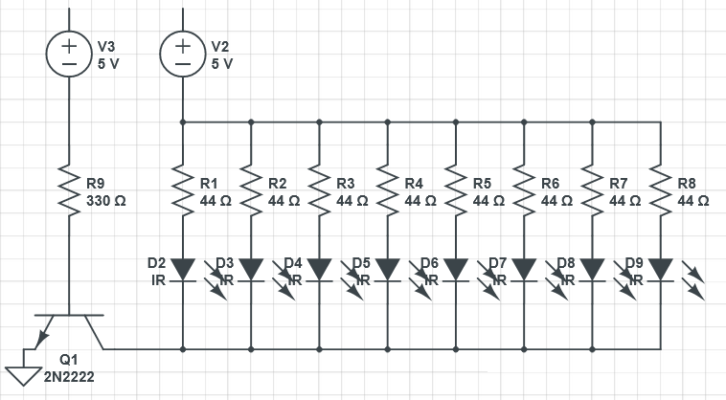

A picture of the setup:

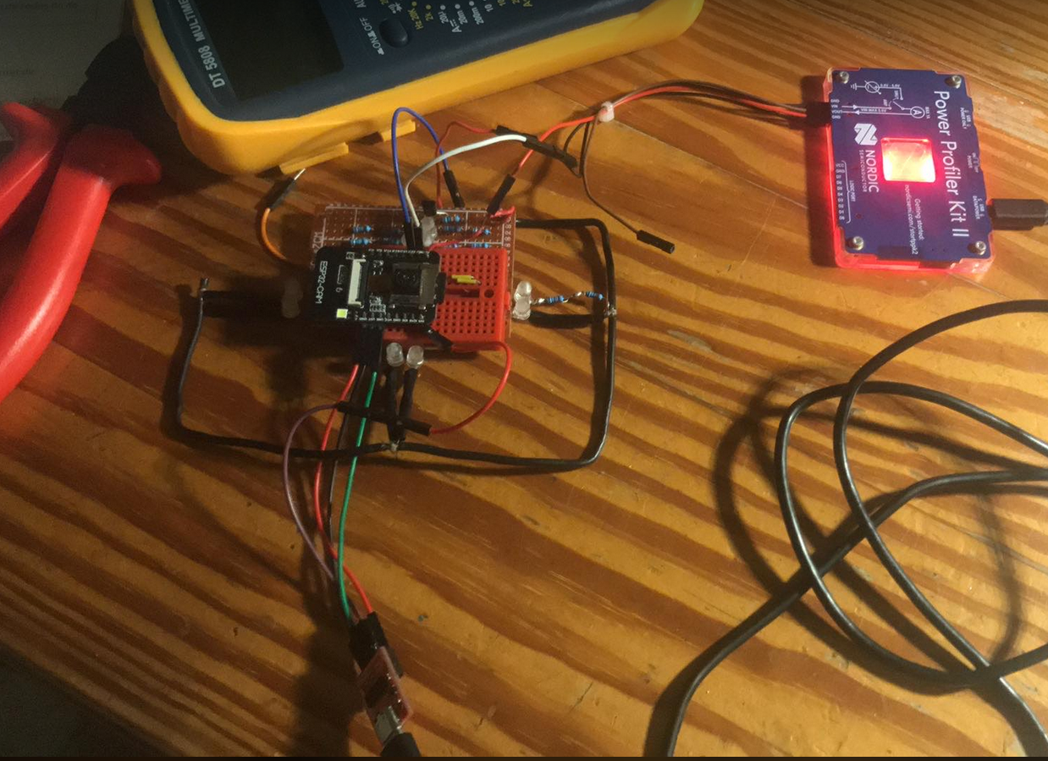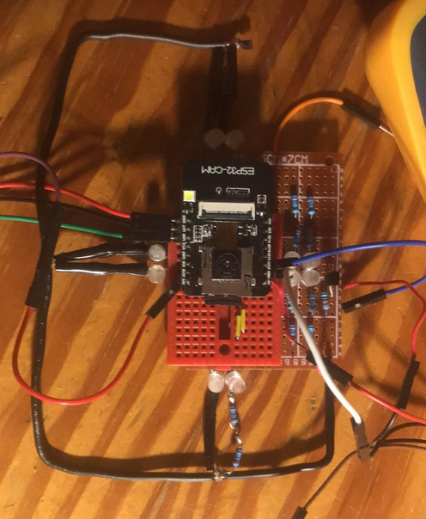

The LEDs are VSLY3850 leds available at : <https://nl.farnell.com/vishay/vsly3850/infrared-emitter-850nm-t-1/dp/1870806> . V3 is a voltage source in this sketch but is actually connected to GPIO pin 12 of the esp32 board in the setup. Calculating the current draw we should get about 640 mA in ideal circumstances in reality I found that it is more around 620 mA for reason and calculation see chapter “IR visibility” subchapter “8 leds at 620 mA under water”.

## Platform

I use the esp32-cam kit. Screw out the camera lens and cut out the red film. Then screw the lens back on to make the camera pick up on IR light. The camera is connected to the esp32 board through a cable that connects to a specific camera port. Esp32 board is powered trough the 5v GPIO pin because I read online that powering trough the 3.3v pin can cause problems (Even though while testing I have powered trough this pin multiple times and never had any problems with it. Better safe than sorry). GPIO pin 12 is connected to the 330ohm transistor that opens or closes the 2N2222 transistor. To program the esp32 connect the programmer to your computer on one side and use jumper wires to connect the other side to the correct GPIO pins of the esp32. Be careful, the programmer I use outputs 3.3v and should be connected to the 3.3v GPIO pin of the esp32 board, not the 5v pin.

## Model

I use FOMO which is a customization of MobileNetV2, made by the edge impulse team. The version of MobileNetV2 I used was 0.35 for both models. I acquired data by placing the setup with camera and LED’s with the camera down in a multitude of see trough containers. Model 2 used only a glass container. Pictures are taken of the crabs and stored on an sd card. All pictures and code to take and save pictures can be found on github: <https://github.com/Joost42/MAP2-CRAB> the file in question here is “esp32_takePictureContinious.ino”.

To train the model each picture is squashed to a 96x96 square ratio and then converted to grey scale. See chapter “final model” Model 1 can be found here: <https://studio.edgeimpulse.com/public/231158/latest> . Model 2 here : <https://studio.edgeimpulse.com/public/231662/latest> . After training the model is downloaded as an Arduino library. The model is then added as a ZIP library to the Arduino IDE and included in the file where you want to use it. You can now run the inference after taking a picture. To see the code see the github.

## Counting and tracking

Using of centroid tracking with branch and bound algorithm to calculate shortest distance between old and new occurrences. For info about centroid tracking and the branch and bound approach see chapter: “tracking”. For the code check github here : <https://github.com/Joost42/MAP2-CRAB> . Crabs are only counted when they cross an imaginary line in the middle of the FOV at x = 43. The total count of crabs is stored in EEPROM so that it persists trough reboots.

To make our tracking as accurate as possible we aim for an FPS that is as high as possible. To achieve this while also keeping power consumption down we go into deep sleep for 0,3s after which we wake up which takes on average a little bit less than 0.7 s, and immediately turn on the IR LEDs, then we wait 100 ms so the LEDs can turn on after which we take a picture and run our inference. If we detect a crab we immediately take another picture and run our tracking on the new picture. We continue doing this until no crabs are detected in a picture. Then we go back to deep sleep for 0.3 s. For the code that implements of this see github. To see what effect this has on overall power consumption see the final power consumption chapter.